Module 8) Bootstrap Basic & Advanced

# Q 1]What are the advantages of Bootstrap?

Ans} Bootstrap make web page responsive. If you using bootstrap in web page it was visible in every device. When you create a web site using bootstrap images and other elements are automatically adjusted. Bootstrap saves many time of developer.

Bootstrap is very easy to use for web developer. If you want to create website for business then you can develop responsive website using this framework.

You can also add a major components using this framework. You can also include major components like navigation bar , Buttons , Dropdown , Forms , Progress Bar etc.

It supports Javascript and CSS also . Bootstrap support both this programming languages.

There are many templates which you can add in your web page . You get support in web development in many ways.

You can also add many types of elements in your web page . There are many types of buttons , navigation bar , dropdown , forms.

# Q 2]What is a Bootstrap Container, and how does it work?

Ans} Bootstrap Container have a two type of container there are

1. Container :- Container gives content in center . It will give a gap left and right corner in container.

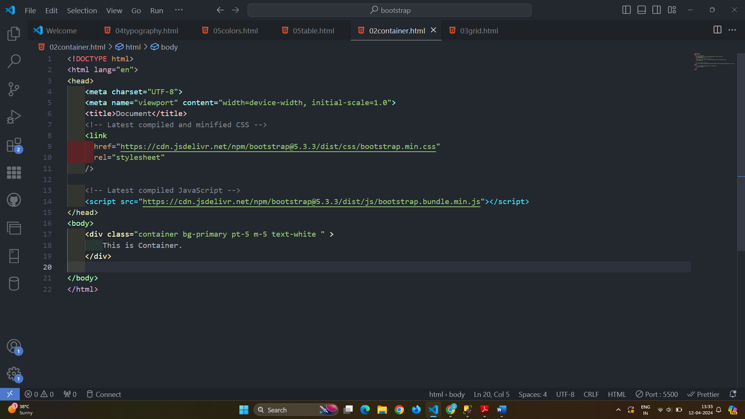

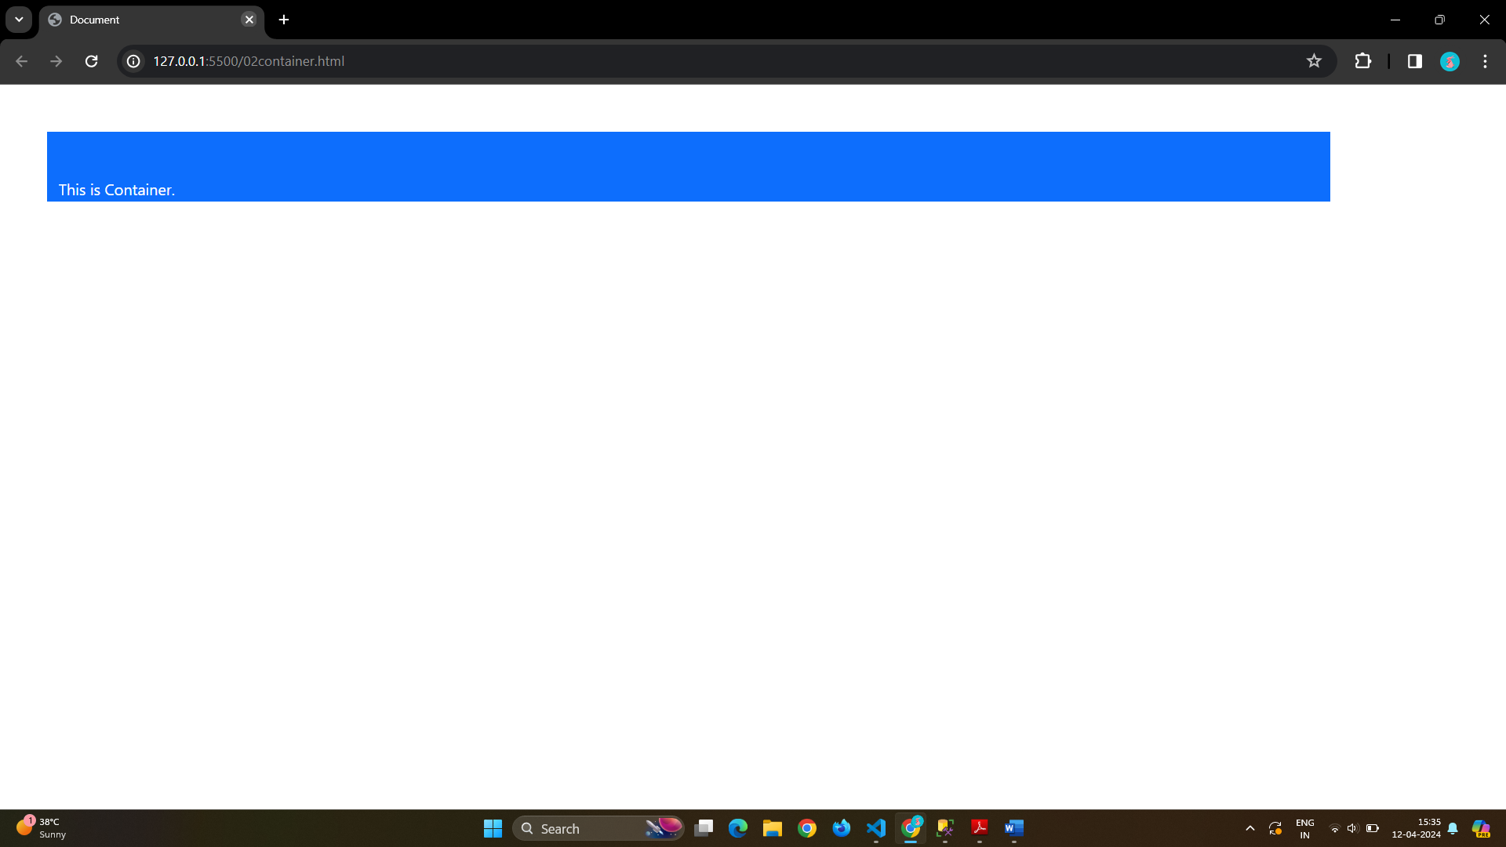

(2)Container fluid :- Container fluid gives full container in full screen .

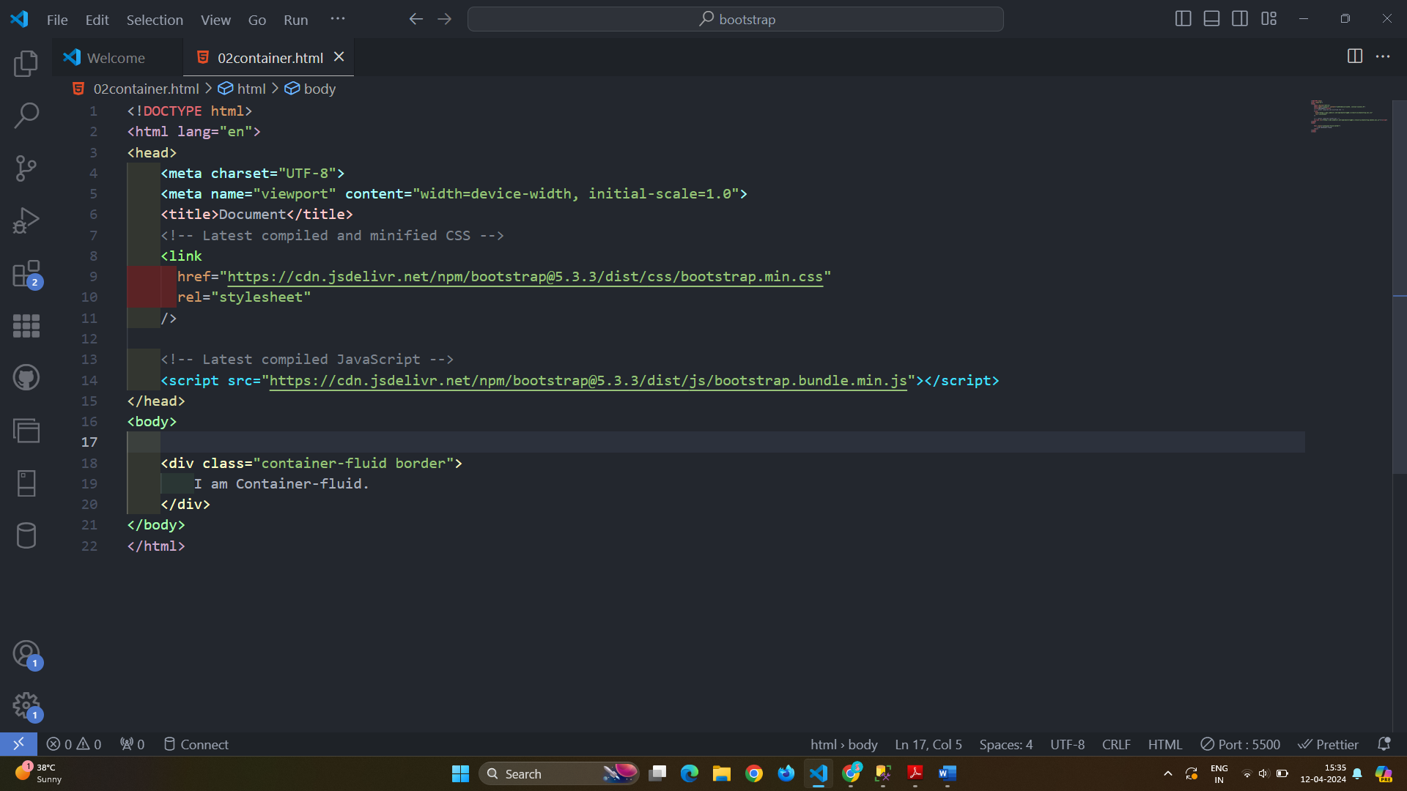

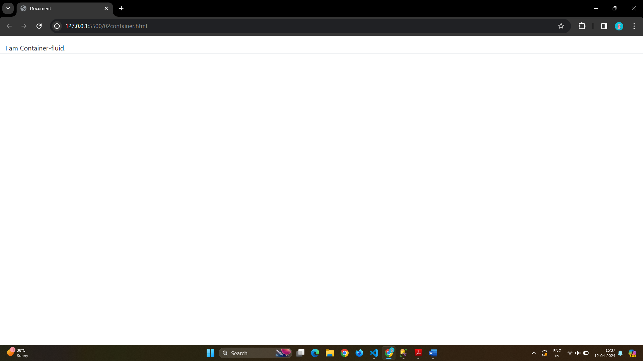



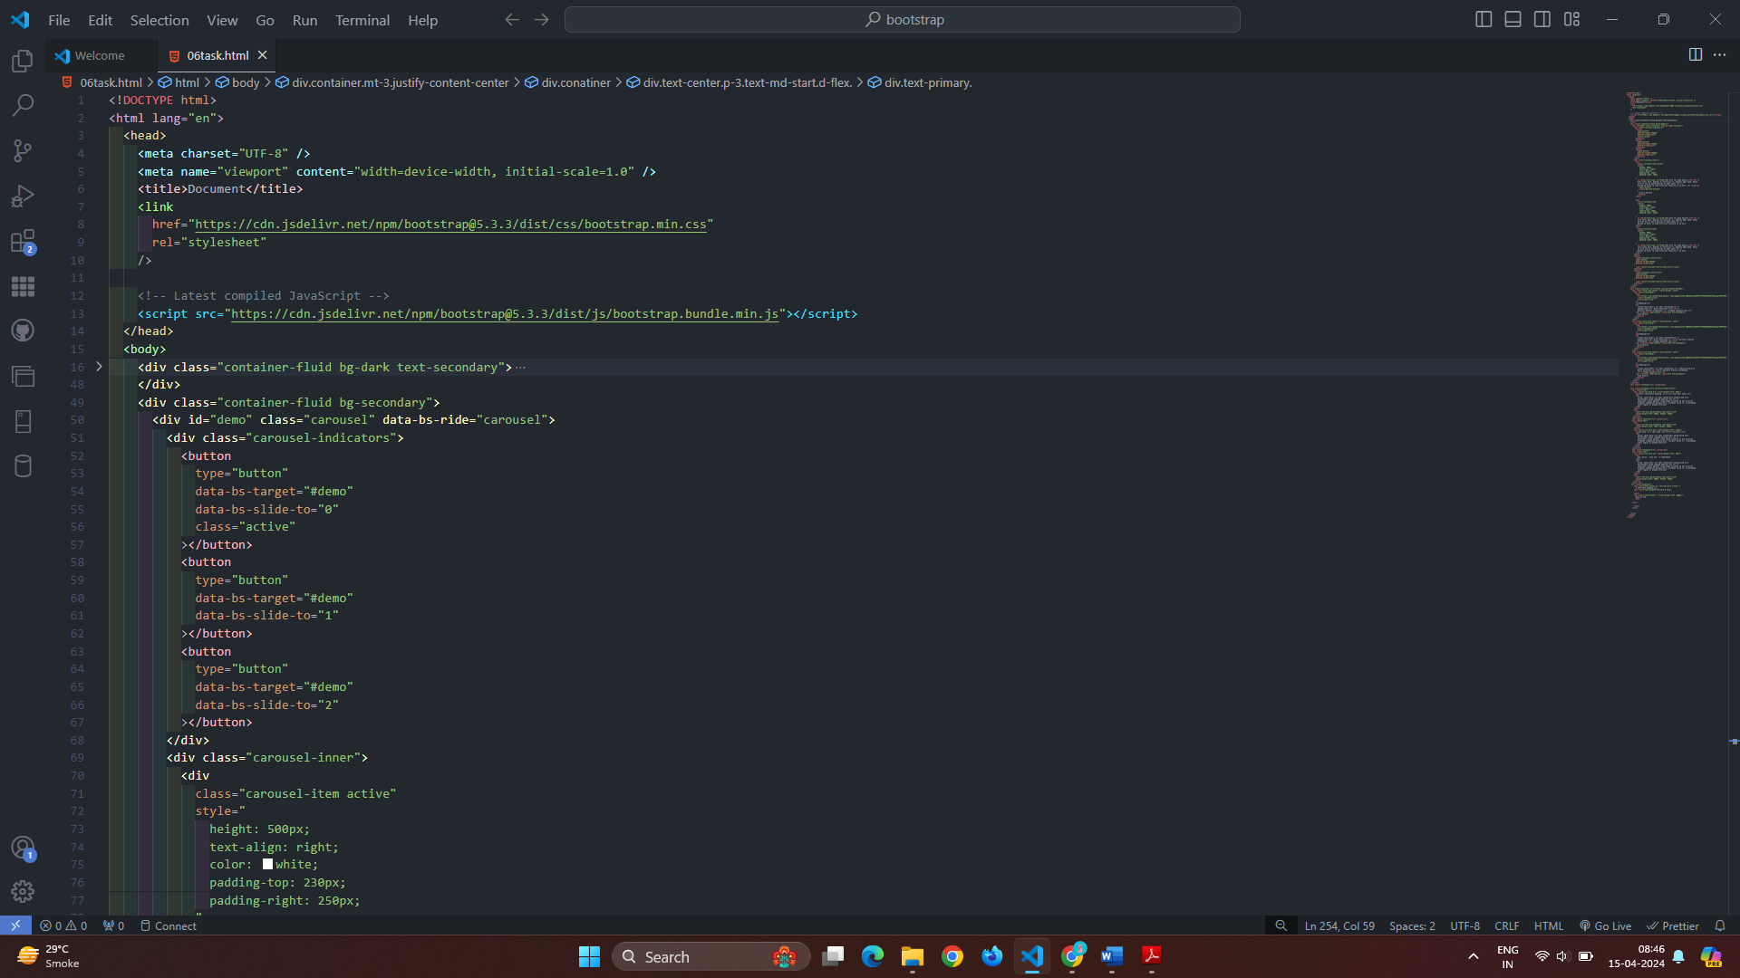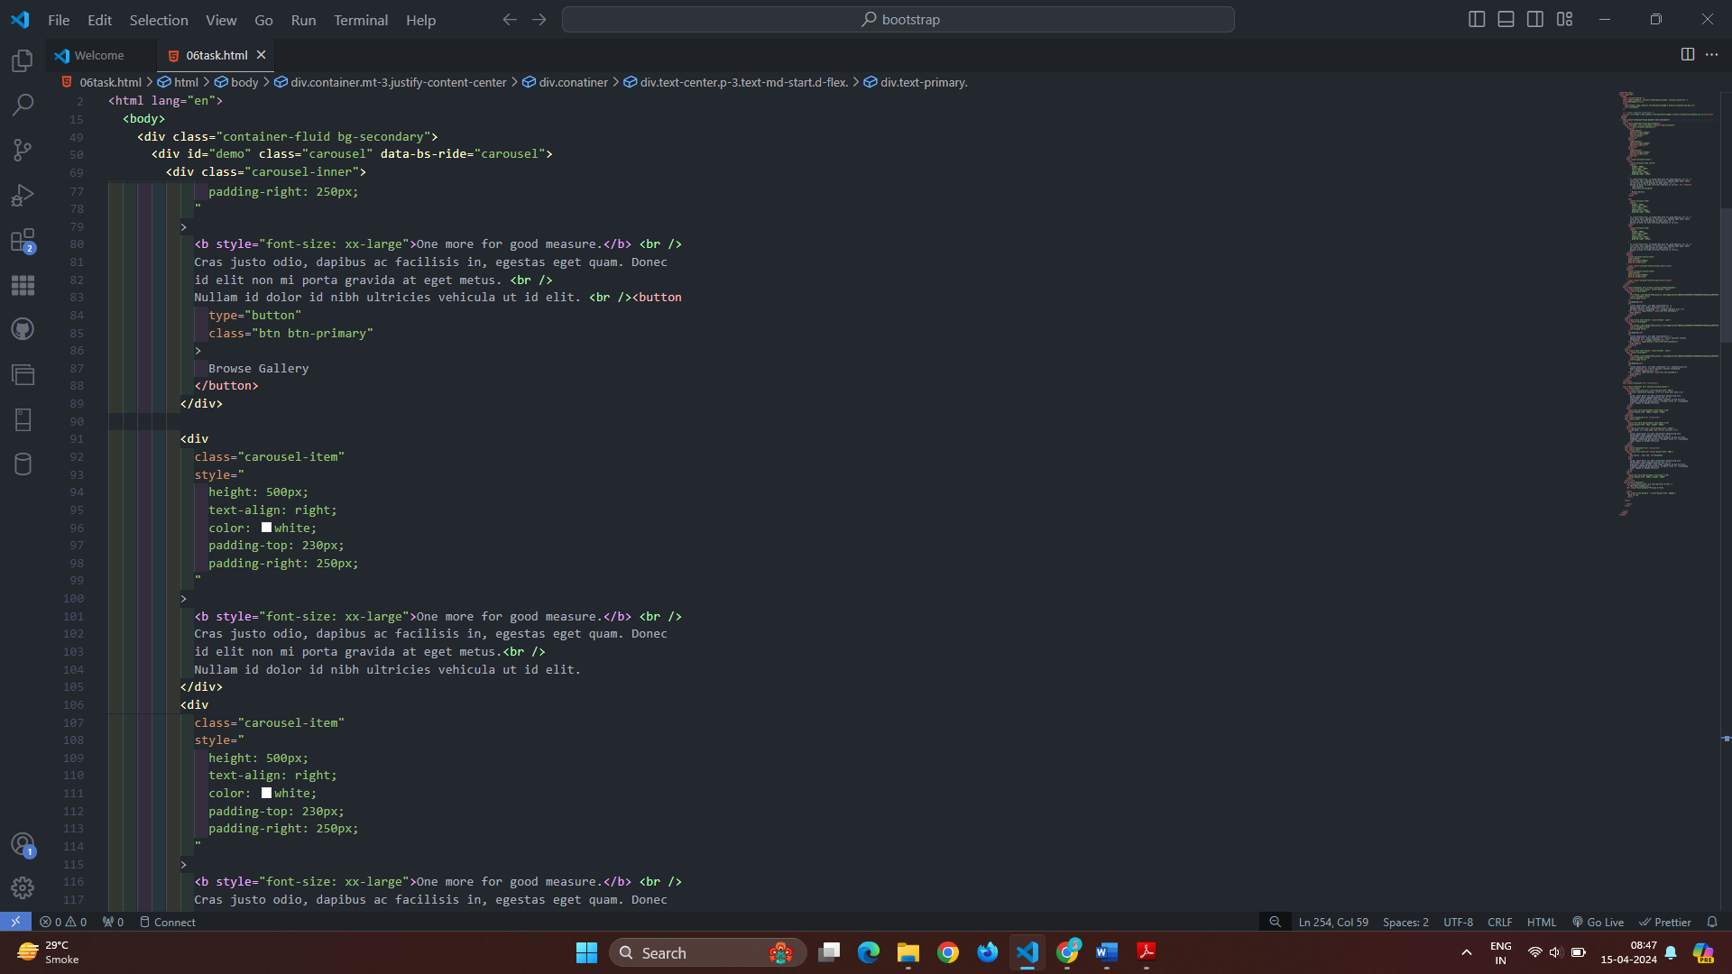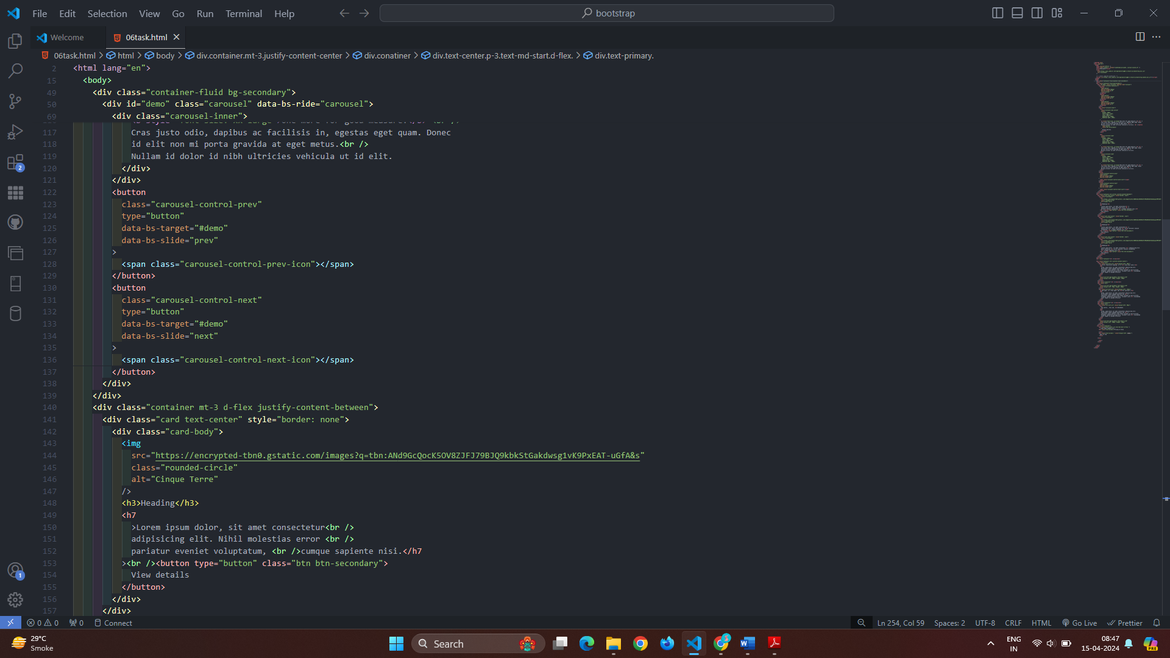

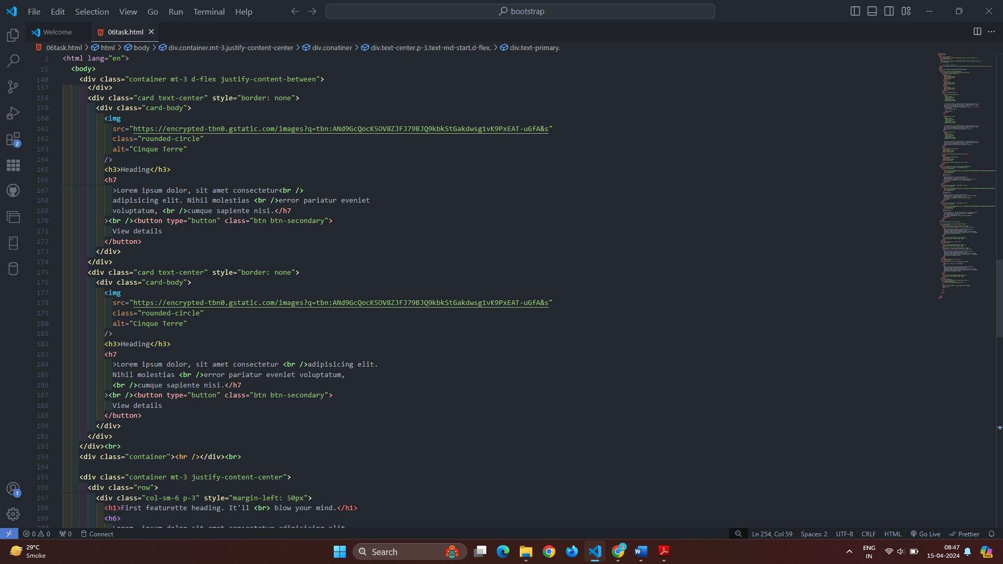

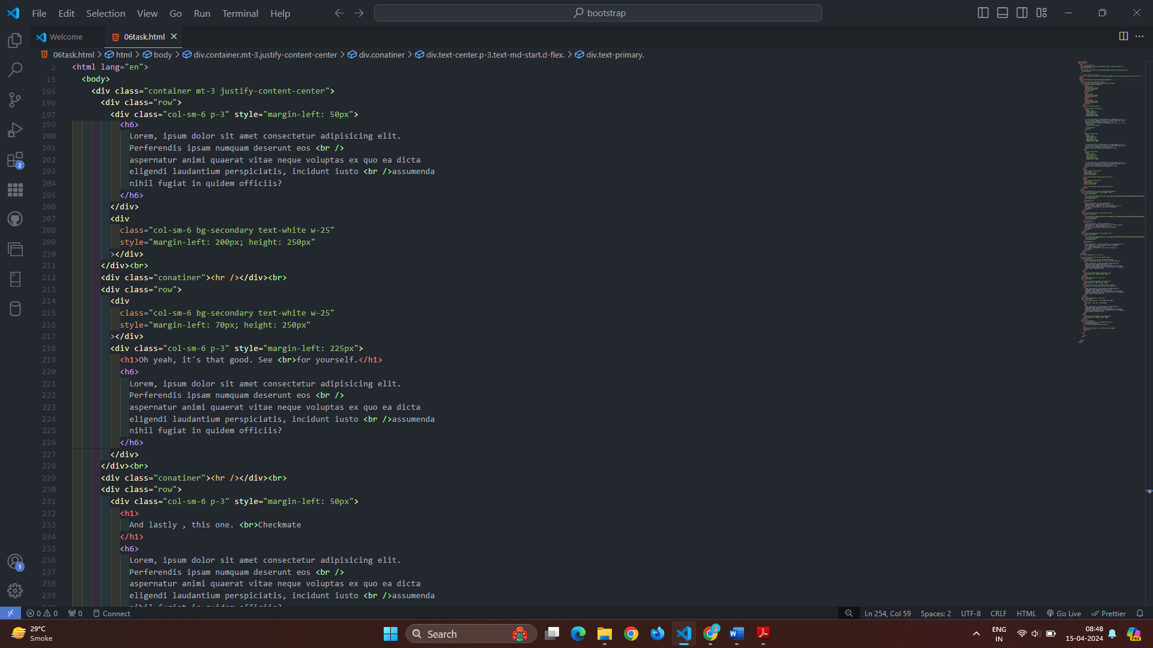

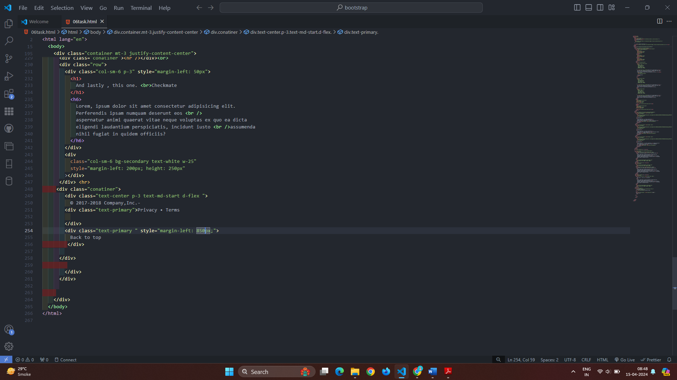

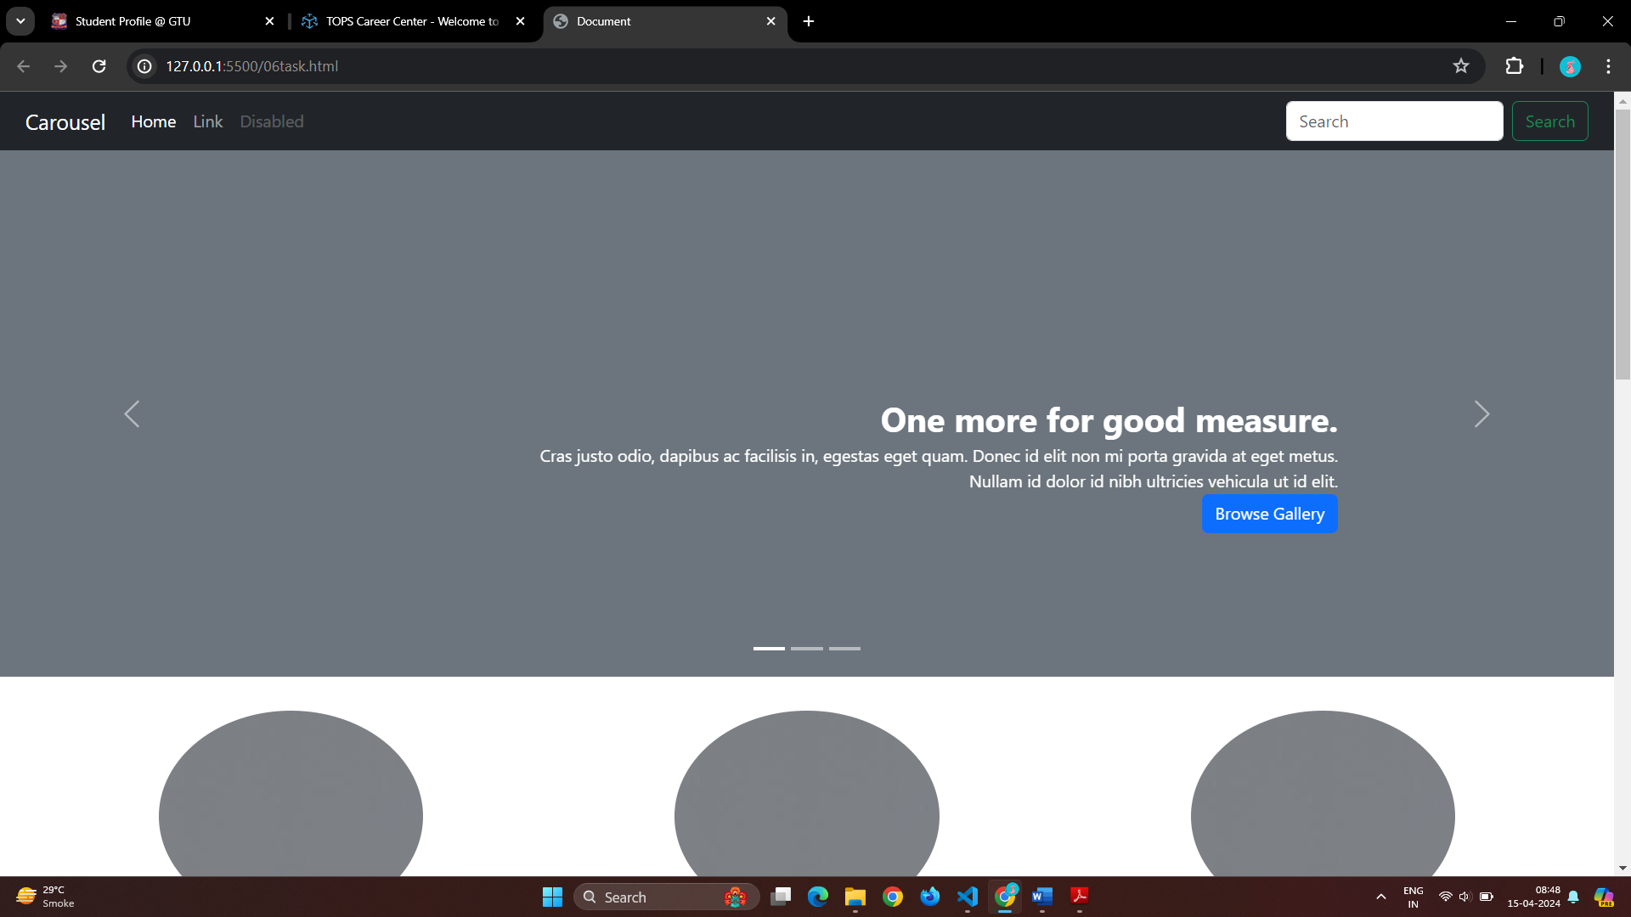

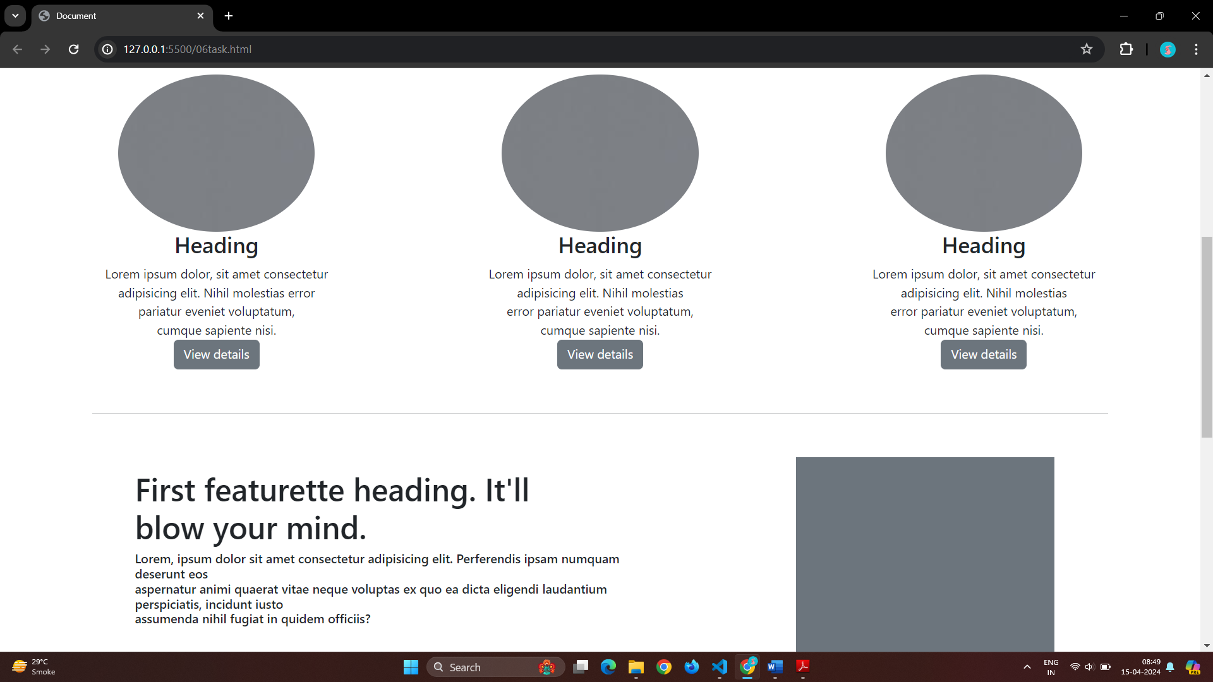

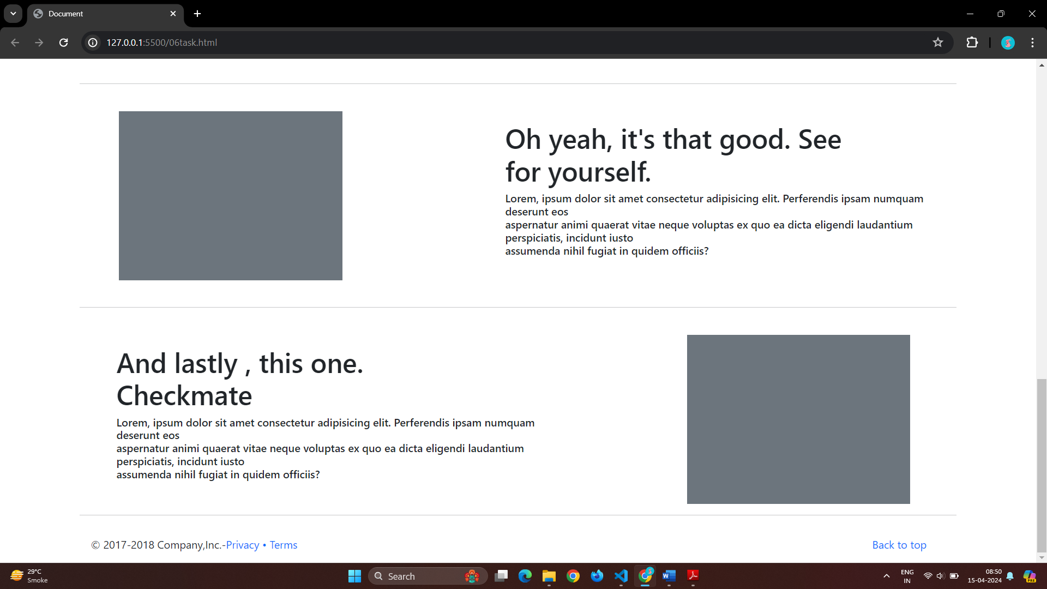

# Q 3]What are the default Bootstrap text settings?

Ans} There are a setting in bootstrap for text it was <h1> to <h6> which was give a font size.

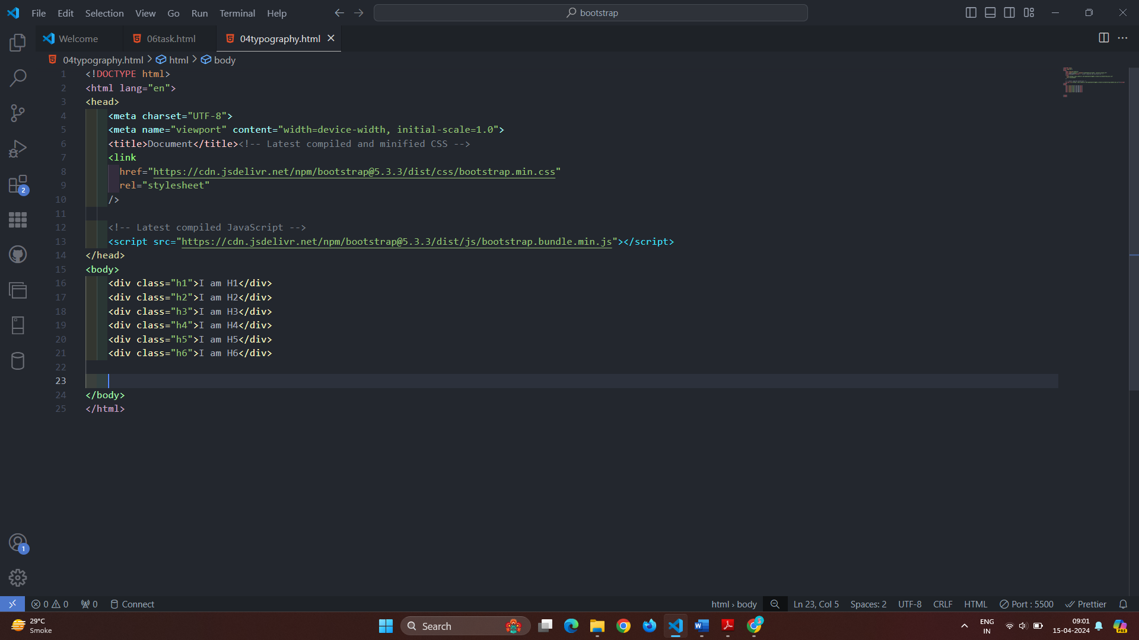

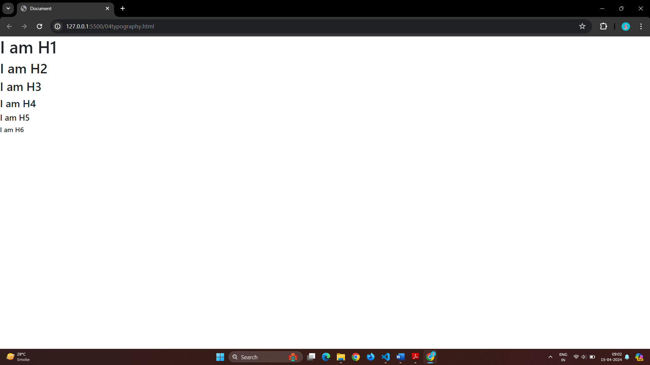

In bootstrap text setting there are a display 1 to display 2 it will also give a different style of font.

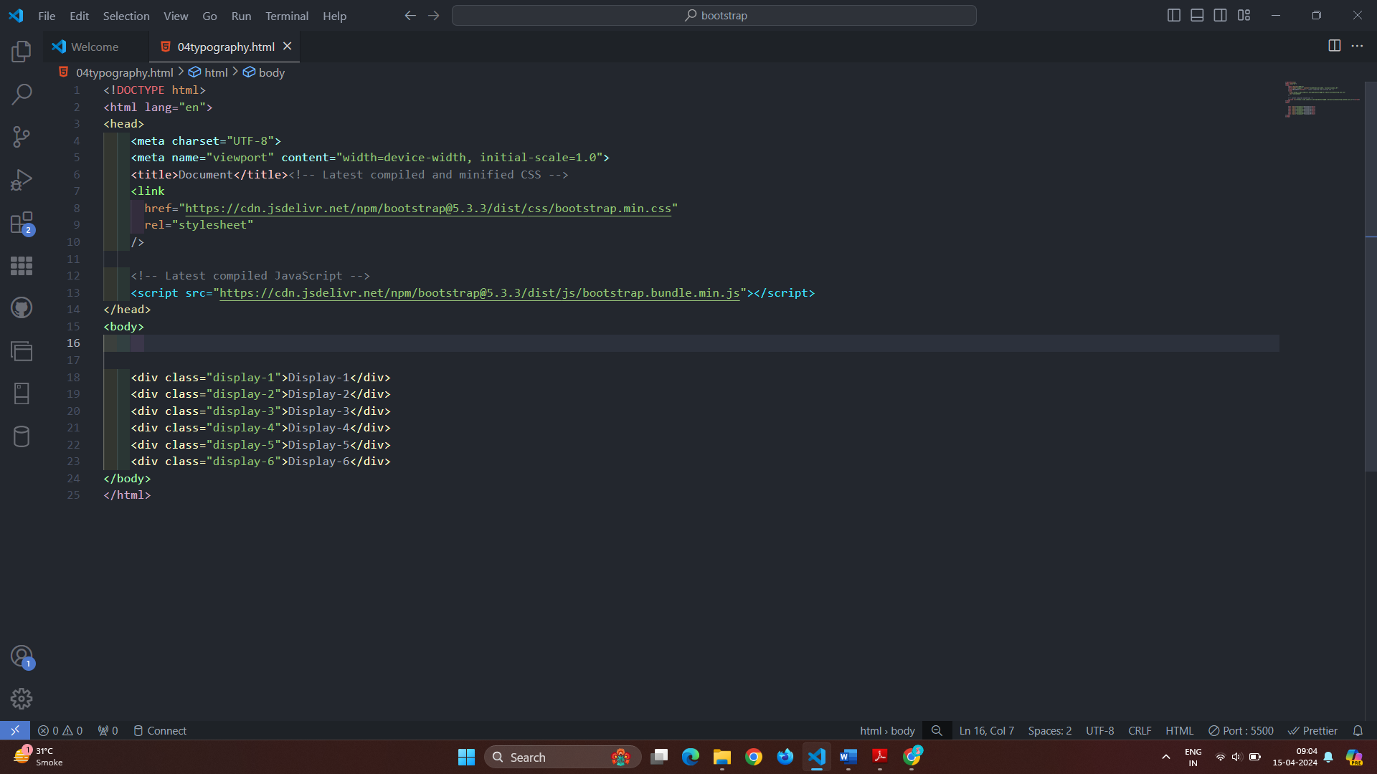

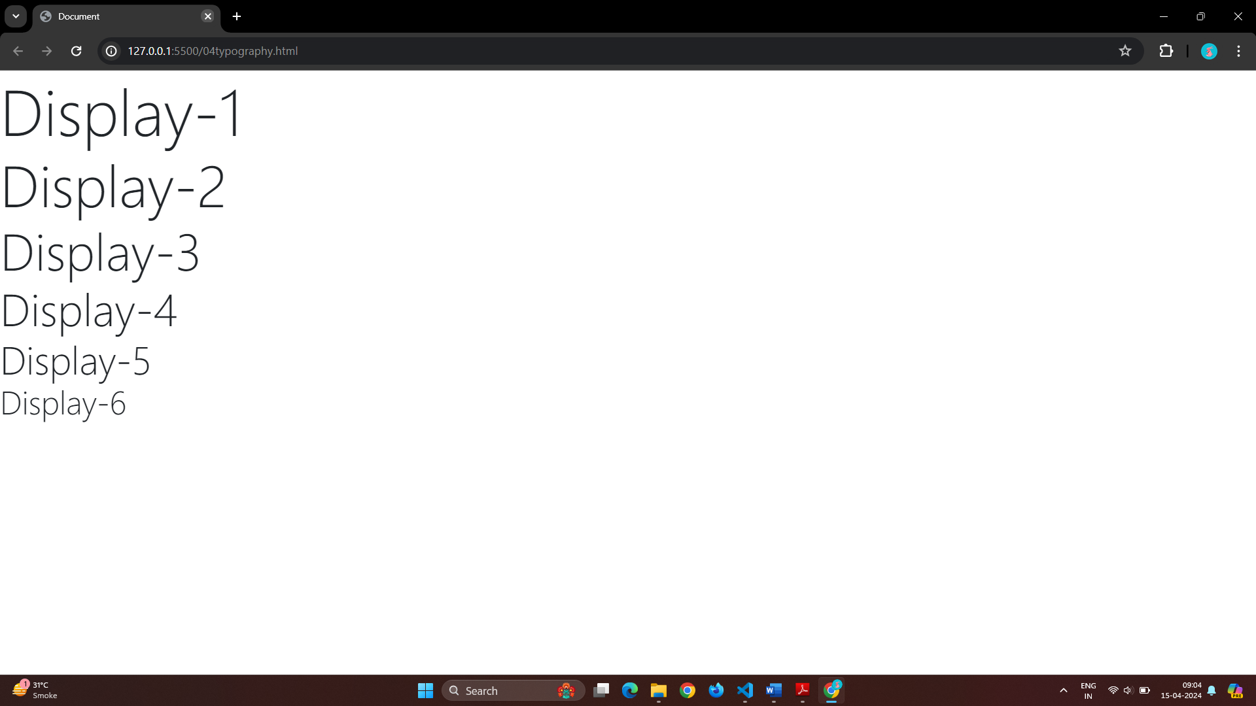

In Bootstrap 5 the HTML <small> element is used to give a font size small it will give a font size secondary text heading.

Bootstrap 5 will style <mark> it is used to give a highlight to text with yellow color.

<abbr> is also used to style a text it is used to give a dotted line under the text.

There are also a element which is <dl> it is used to give a description lists.

<pre> class is used to give a as it it code to HTML.

Class text- start is used to put a text in starting of the page.

Class text- end is used to put a text in ending of the page.

Class text- center is used to put a text in center of the page.

Nowrap text indicates no wrap to text.

Class text-lowercase gives a lowercased text.

Class text-uppercase gives a uppercased text.

Class text-capitalized gives a capitalized text.

Class text-muted gives a grey color to text.

Class text-primary gives a blue color to text.

Class text-success gives a green color to text.

Class text-info gives a sky blue color to text.

Class text-warning gives a yellow color to text.

Class text-danger gives a red color to text.

Class text-secondary gives a light grey color to text.

Class text-dark gives a black color to text.

Class text-white gives a default bode color to text.

# Q 4]What do you know about the Bootstrap Grid System?

Ans} The bootstrap grid system have four classes that is:-

1)XS- That is used for phone screen.

2)SM – This is used for tablets.

3)MD – This is used for small leptops.

4)LG – This is used for large desktop and leptops.

In bootstrap there are a class that is row , row class is give a first row to page .

After giving row give in same class the col that give a column to row .

Each row have a total 12 size.

Following is the example of grid in bootstrap.

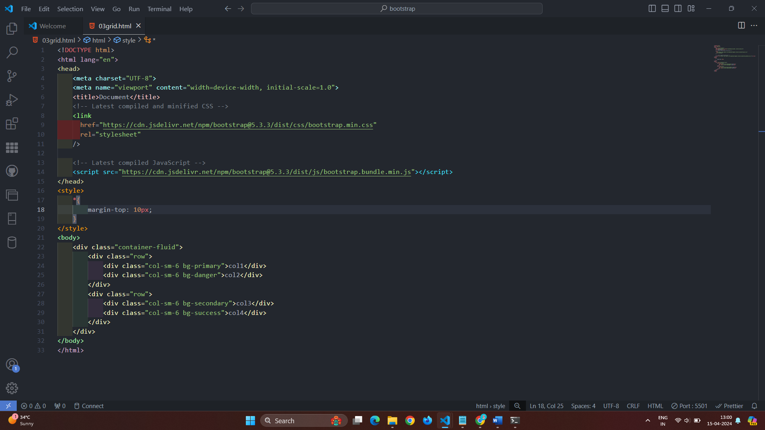

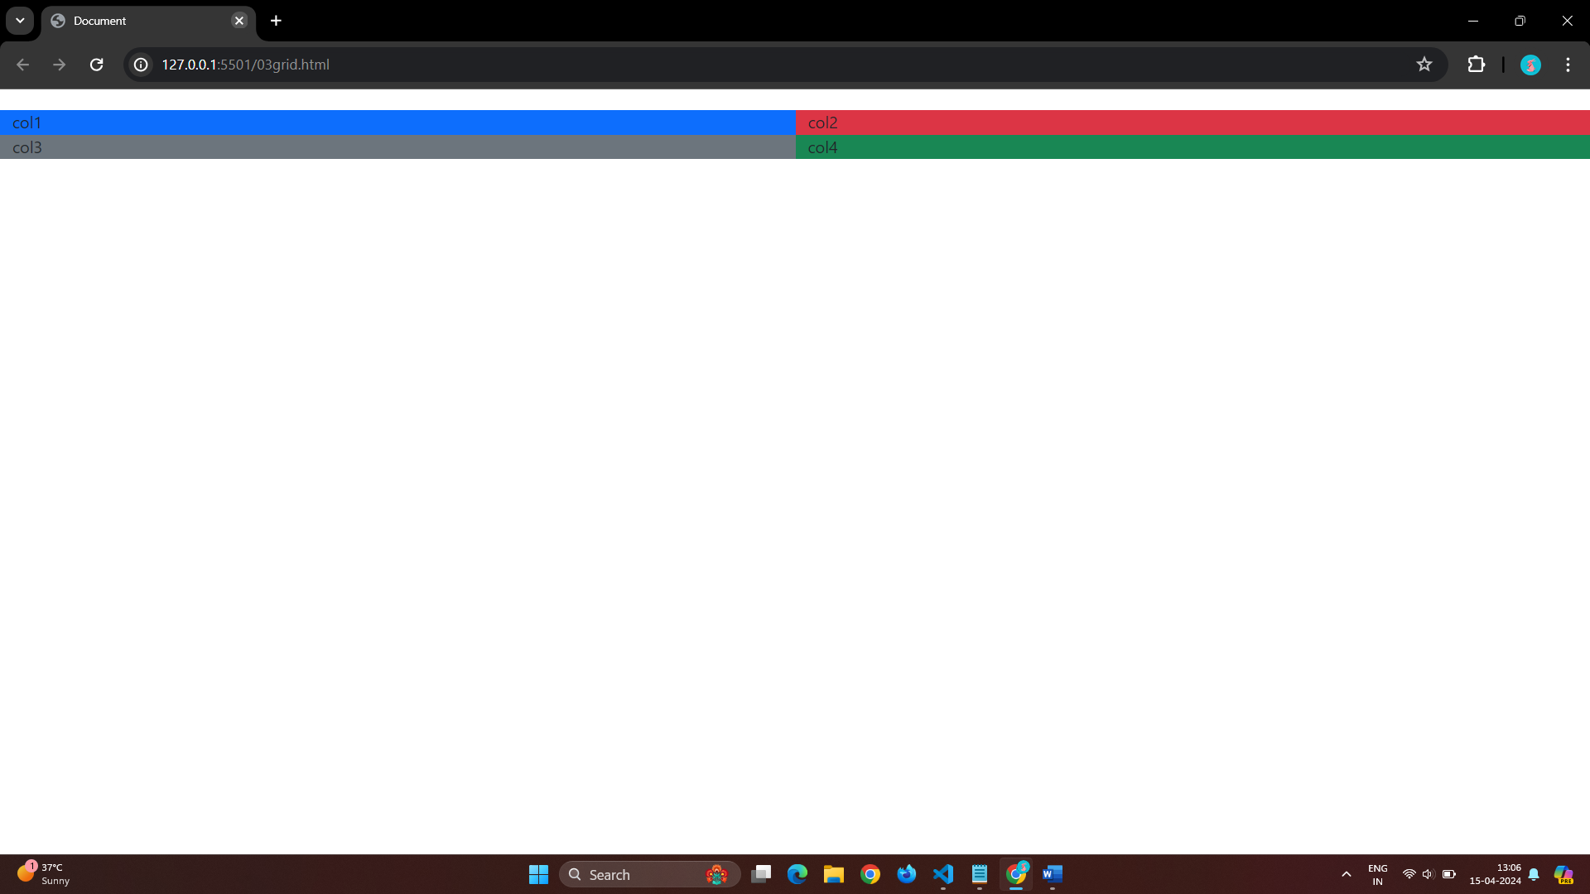

# Q 5]What is the difference between Bootstrap 4 and Bootstrap 5

Ans}

Bootstrap 4:-

It has 5 tiers (xs , sm , md , lg , xl ).

It has limited colors.

It has jquery and all related plugins.

Bootstrap 4 supports IE 10 and 11.

Radio button and checkboxes look different in different browser.

We cannot modify utilities in bootstrap 4.

Columns can be positioned relative.

Bootstrap 4 doesn’t have it’s own SVG icons. We have to use font-awesome for icons.

Bootstrap 5:-

It has 6 tiers (xs , sm , md , lg , xl , xxl).

It has extra colors.

Jquery is removed and switched to vanilla JS with some working plugins.

Bootstrap 5 dose not supports IE 10 and 11.

Radio button and checkboxes not look different in different browser.

We can modify utilities in bootstrap 5.

Columns can not be positioned relative.

Bootstrap 5 have it’s own SVG icons.

# Q 6]What is a Button Group, and what is the class for a basic Button Group?

Ans} There are a class called btn-group that is used to give a group of button .

You can give multiple button in bootstrap using btn-group class.

Following is the example of a button of group.

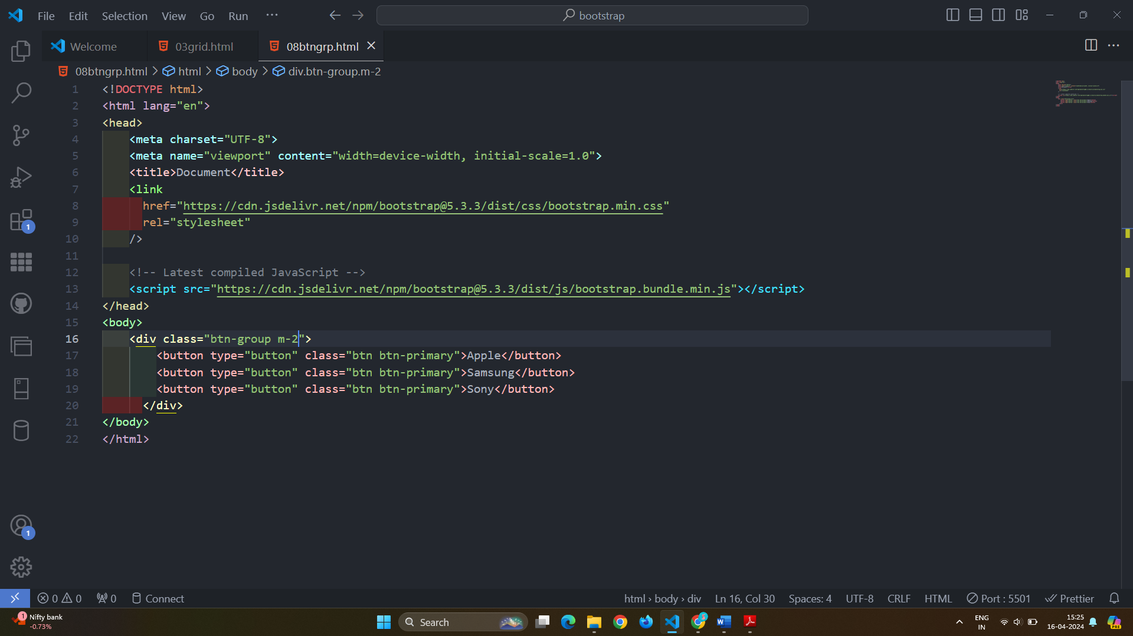

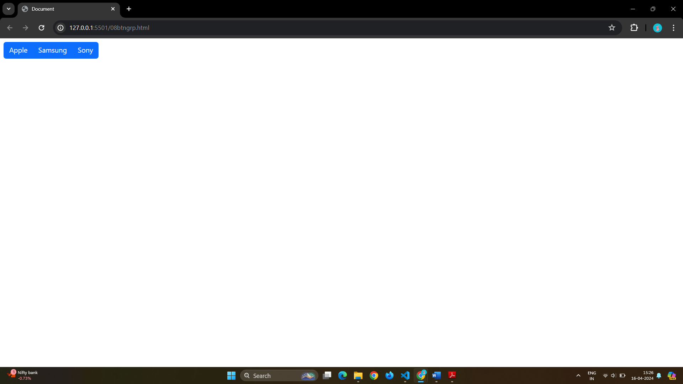

Use the class .btn-group-vertical to create a vertical button group:

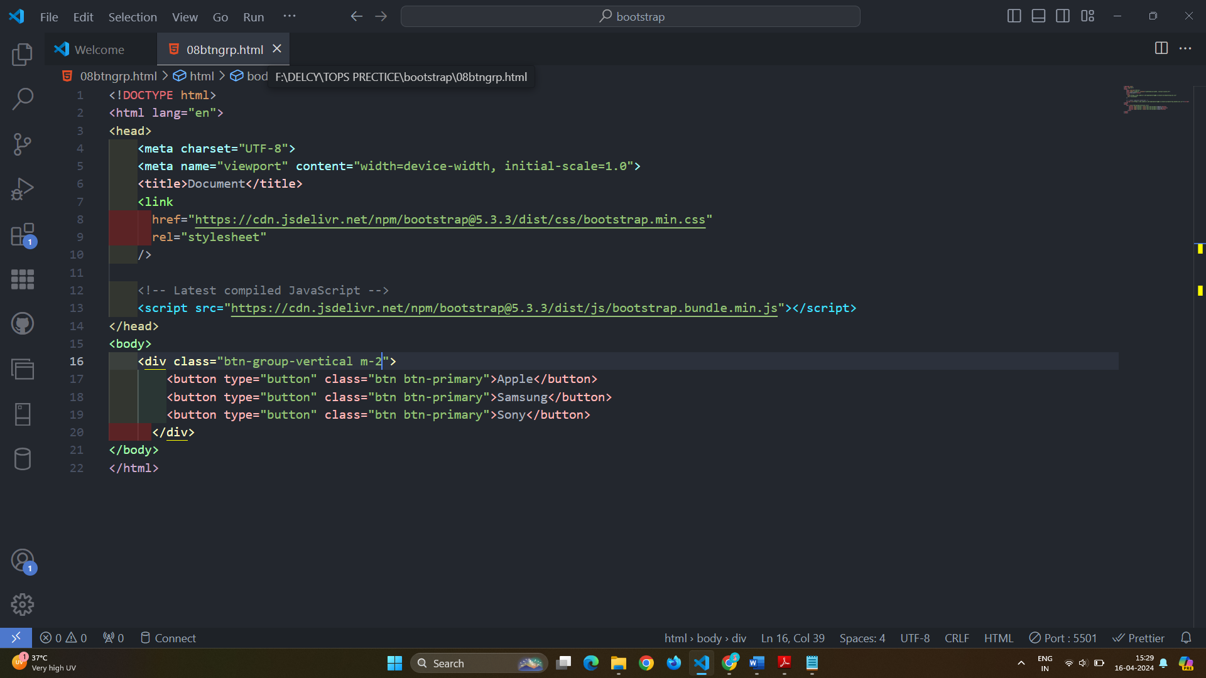

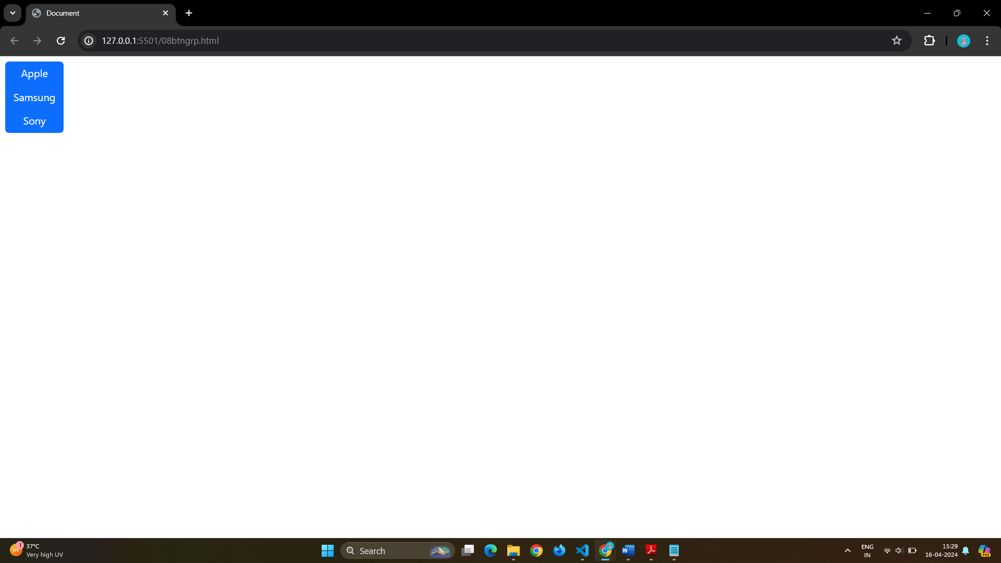

Justified Button Groups

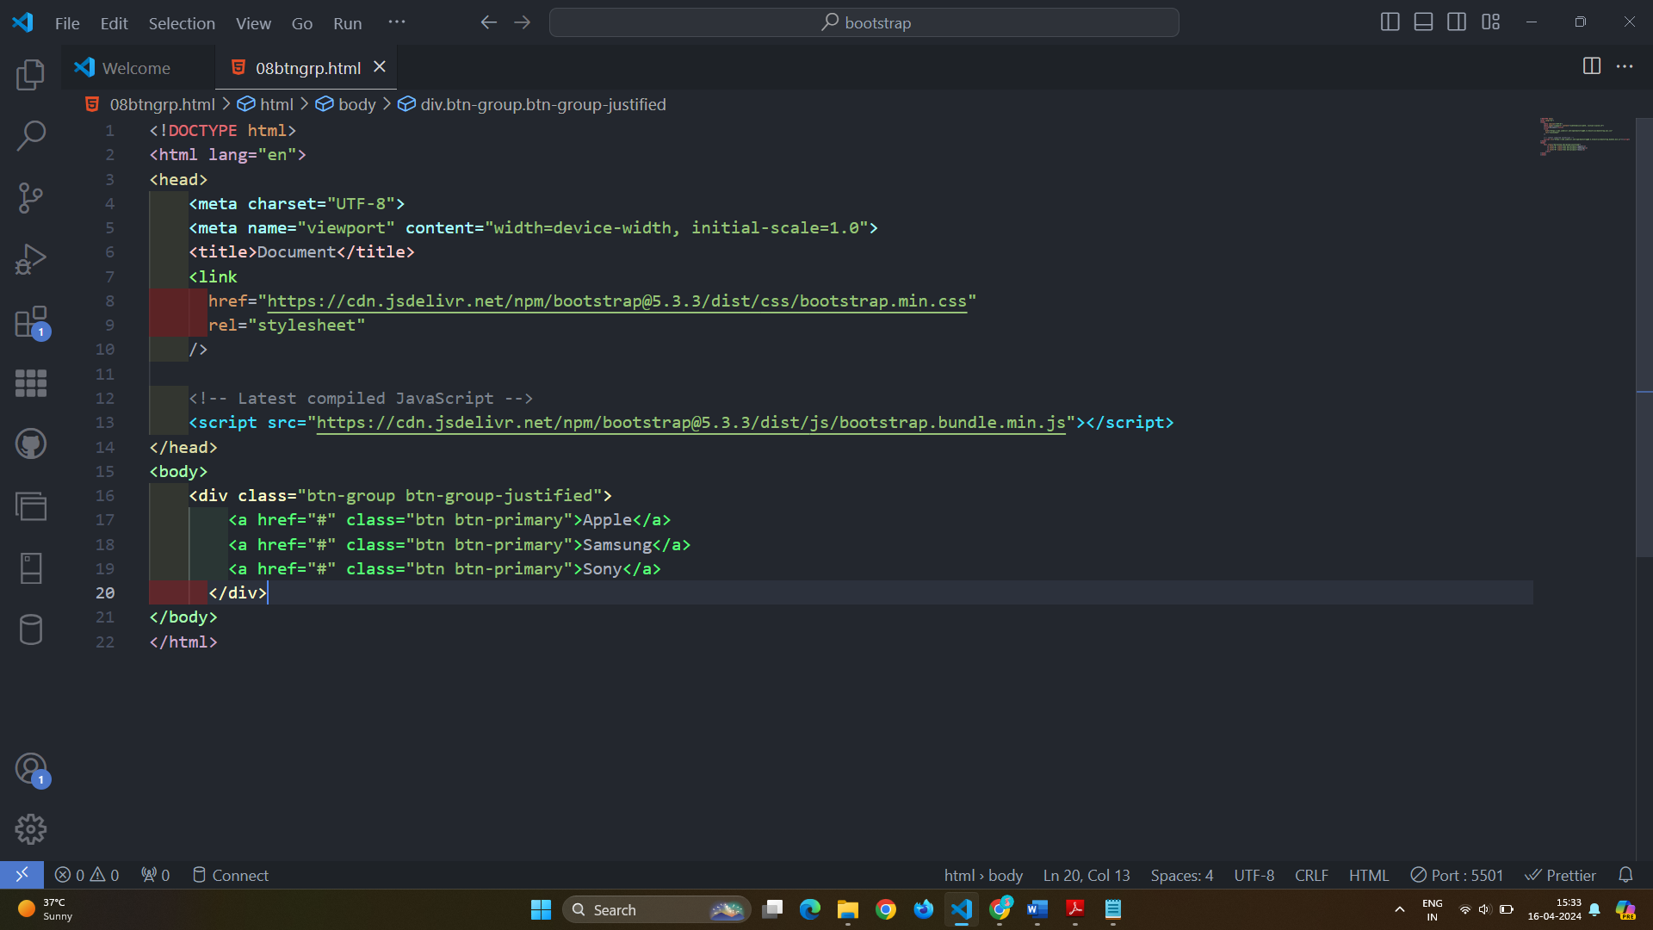

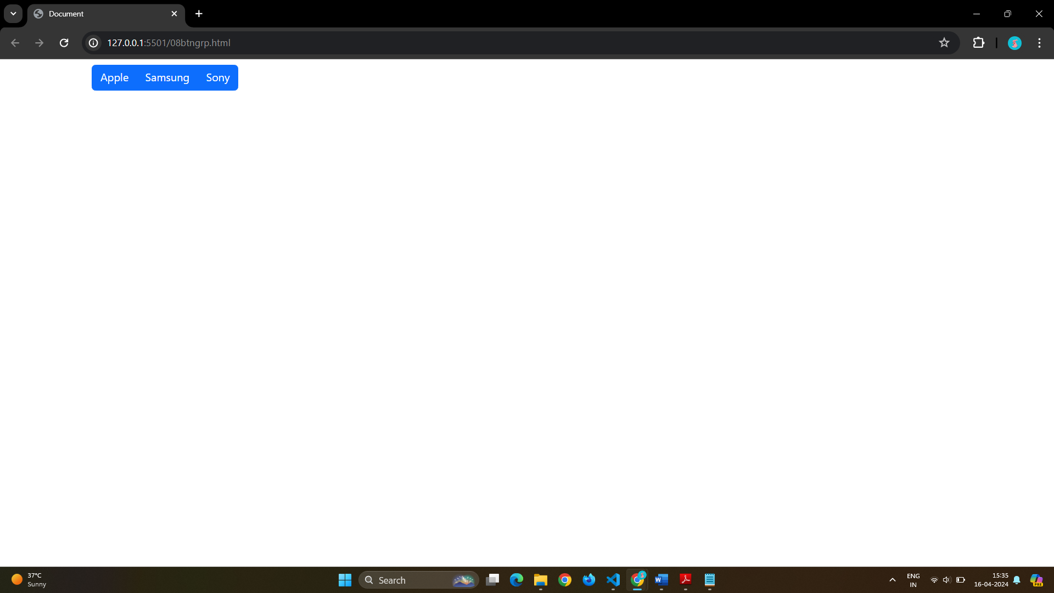

Nesting Button Groups & Dropdown Menus

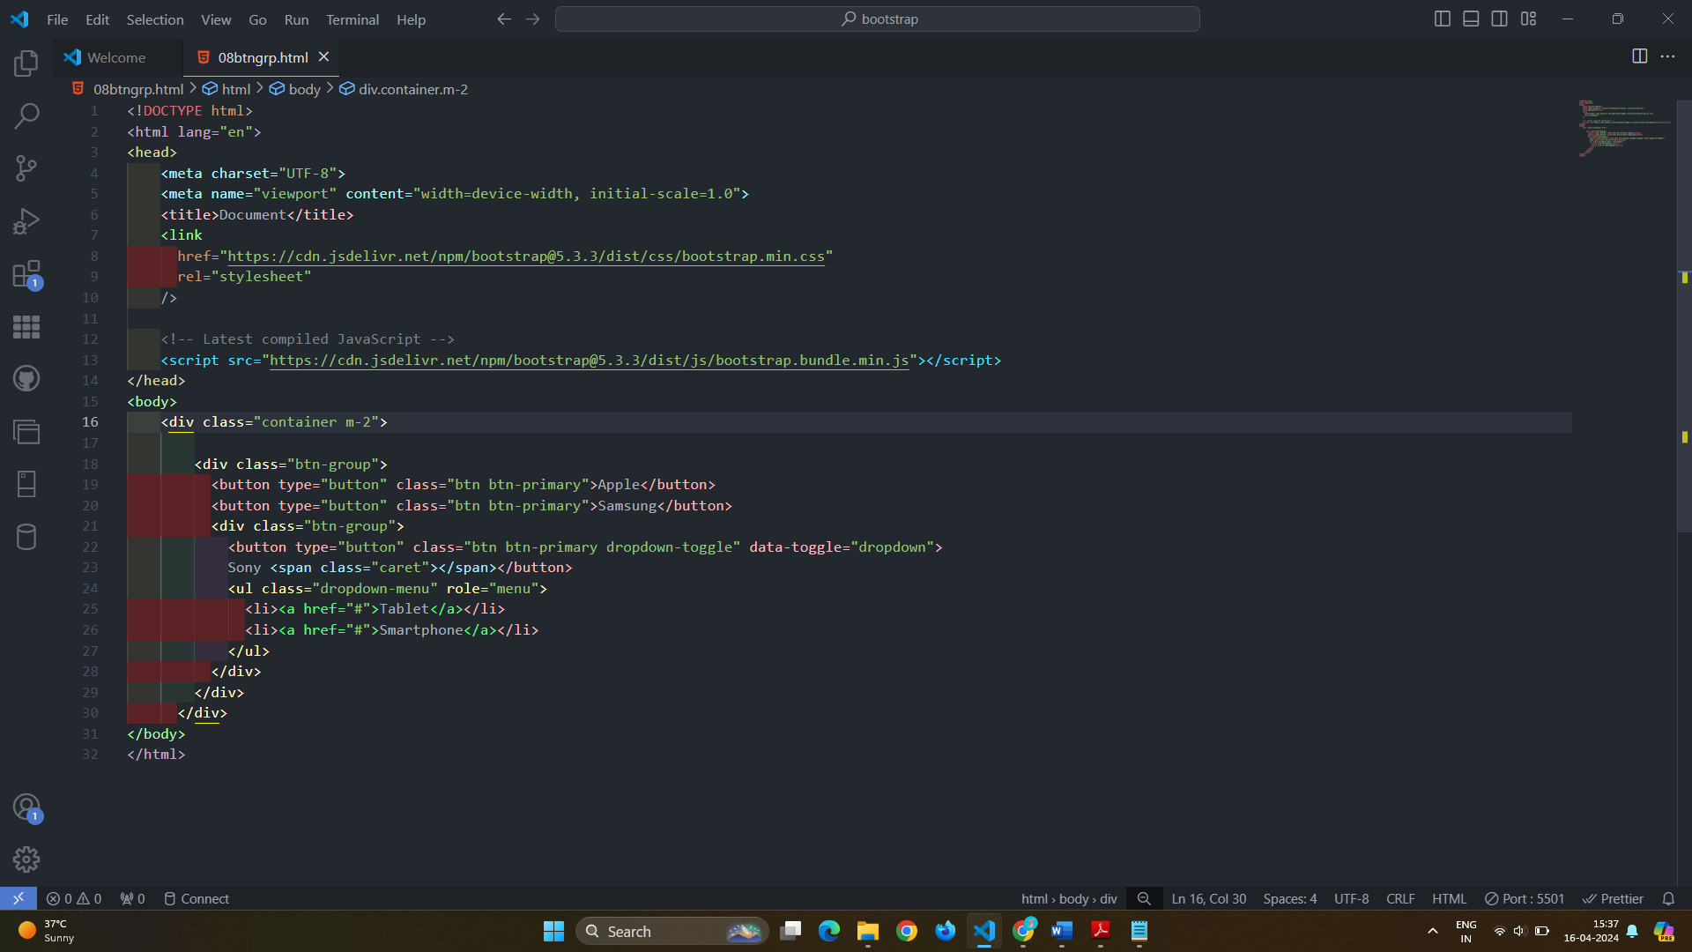

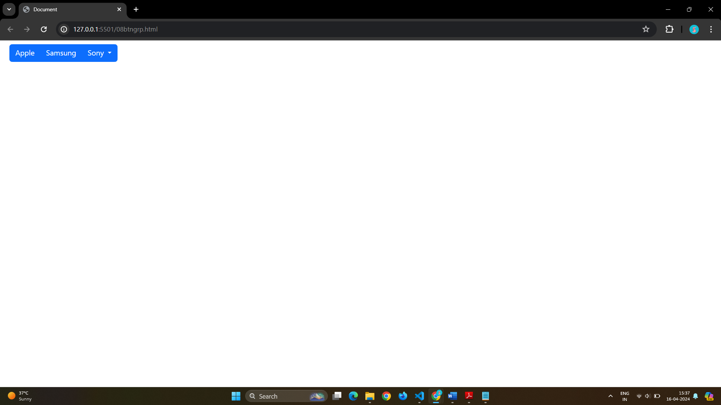

Split Button Dropdowns

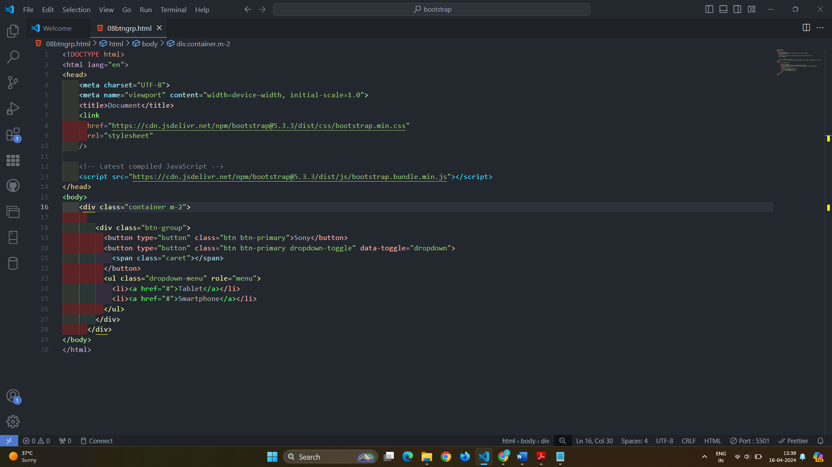

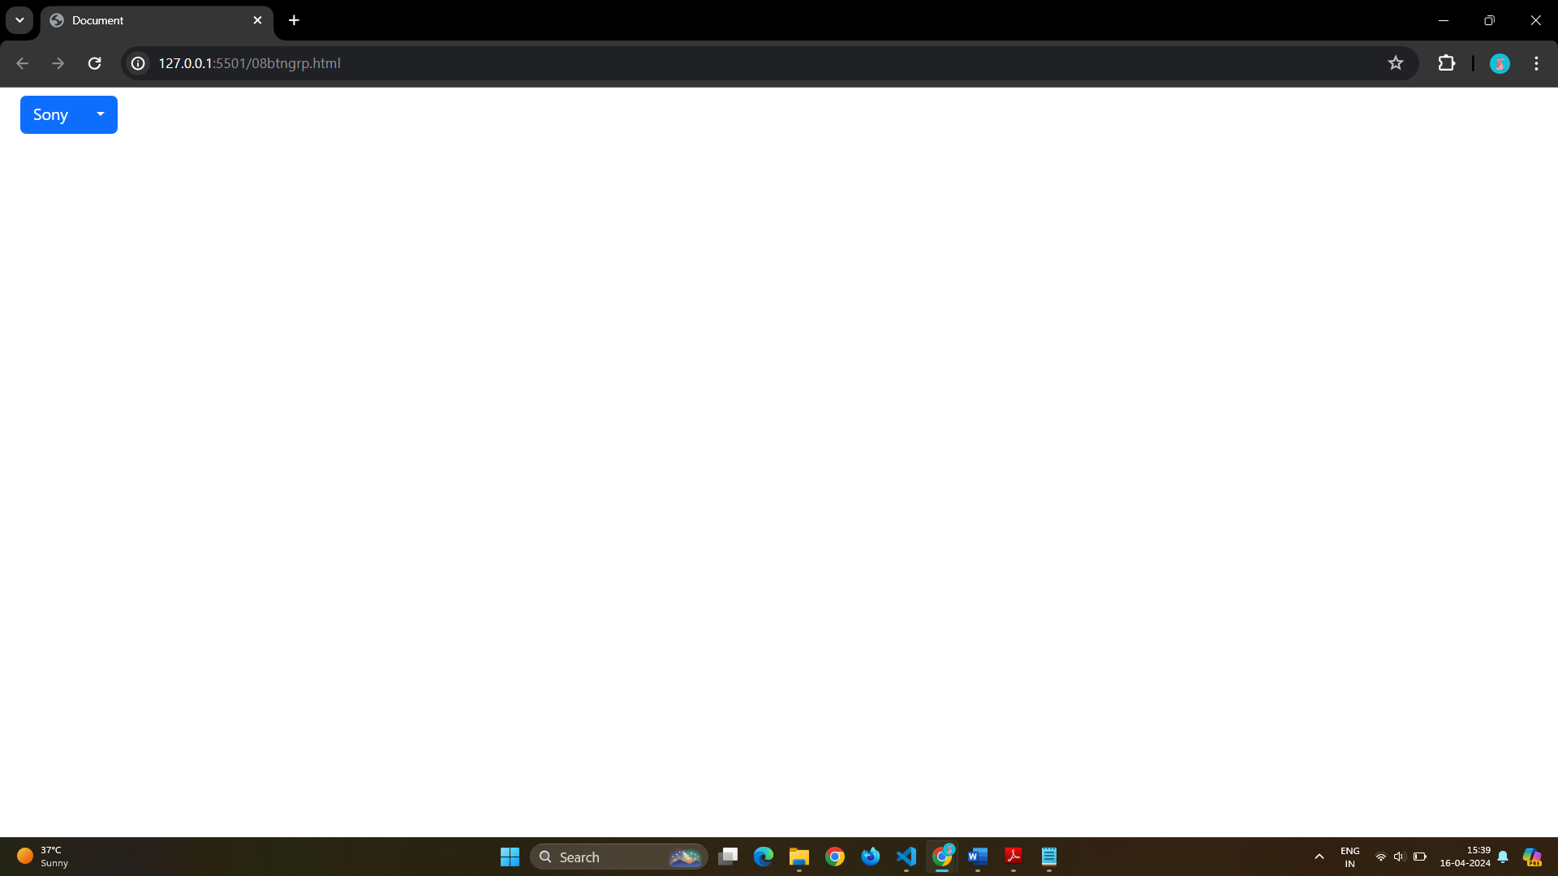

# Q 7]How can you use Bootstrap to make thumbnails?

Ans} Thumbnail

The .img-thumbnail class shapes the image to a thumbnail:

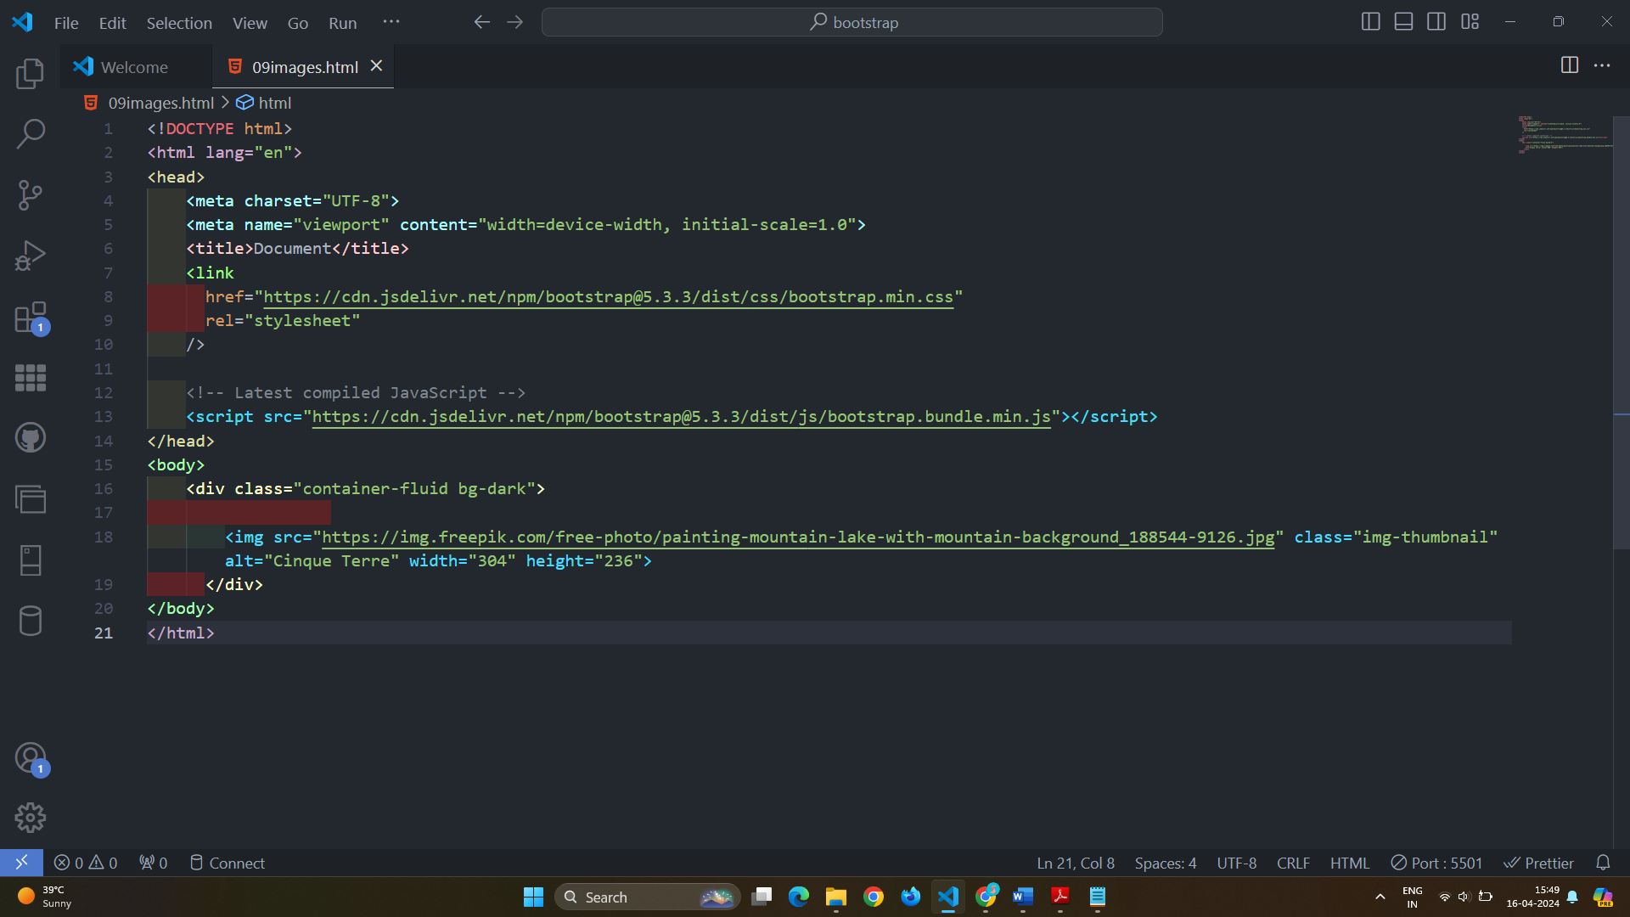

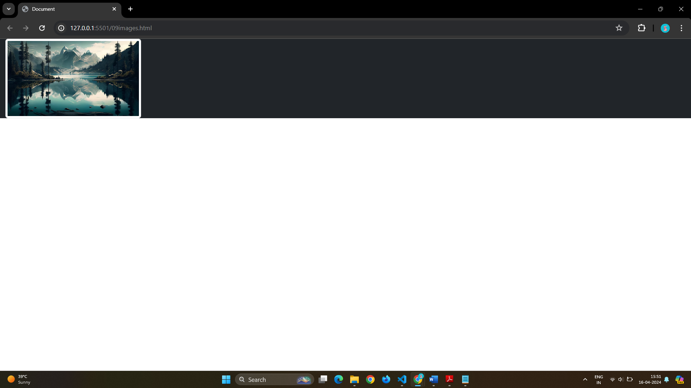

# Q 8]In Bootstrap 4, what is flexbox?

Ans} The flex classes are used to control the layout of flexbox components.

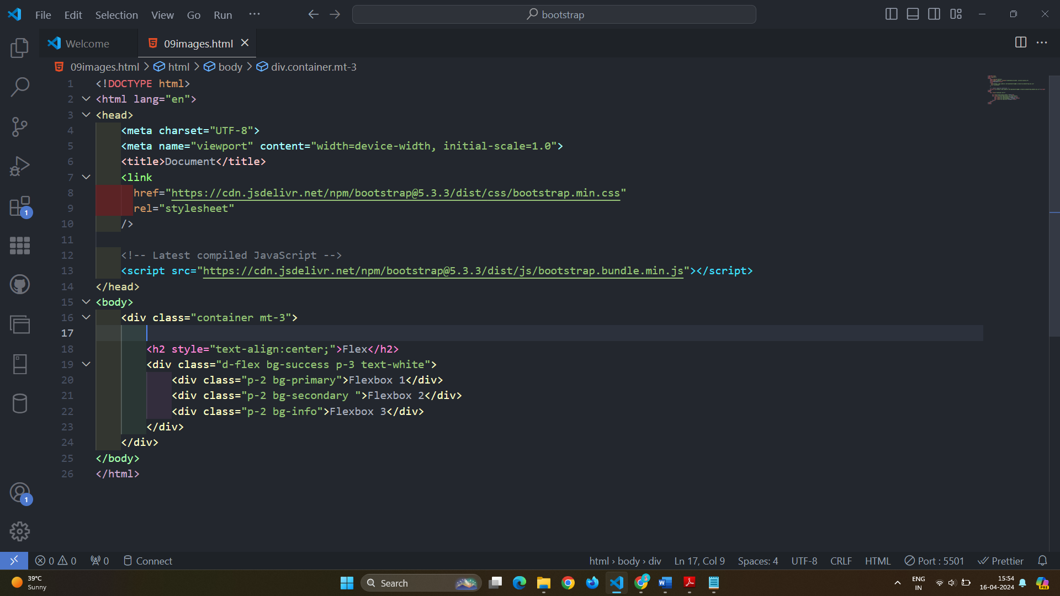

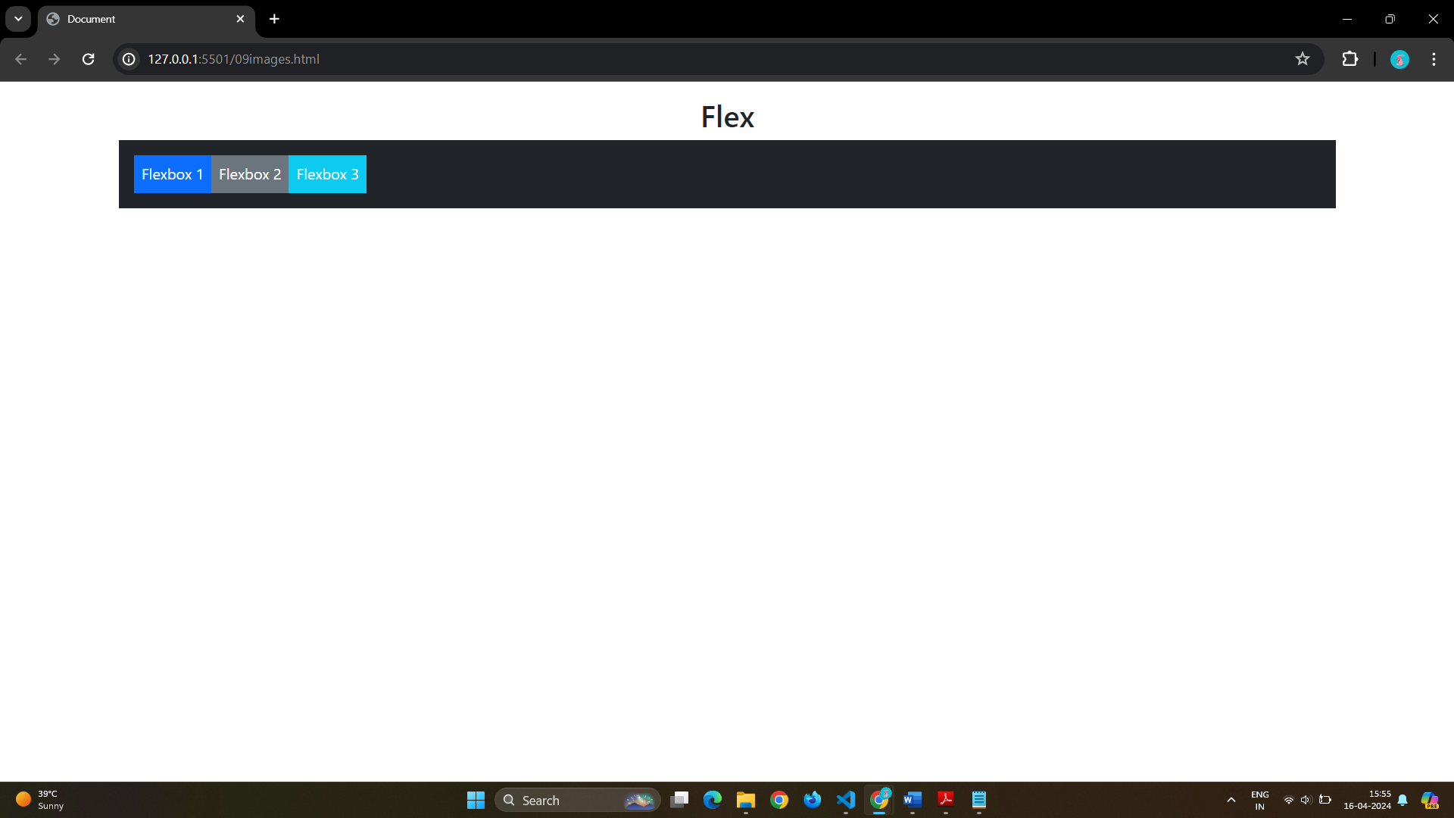

Inline Flexbox:-

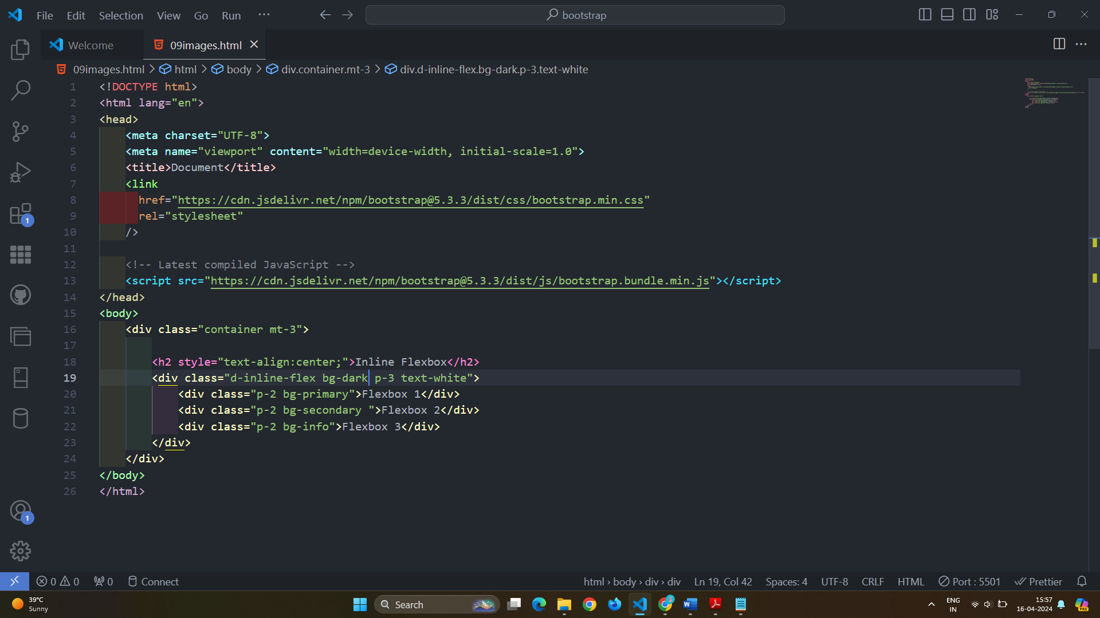

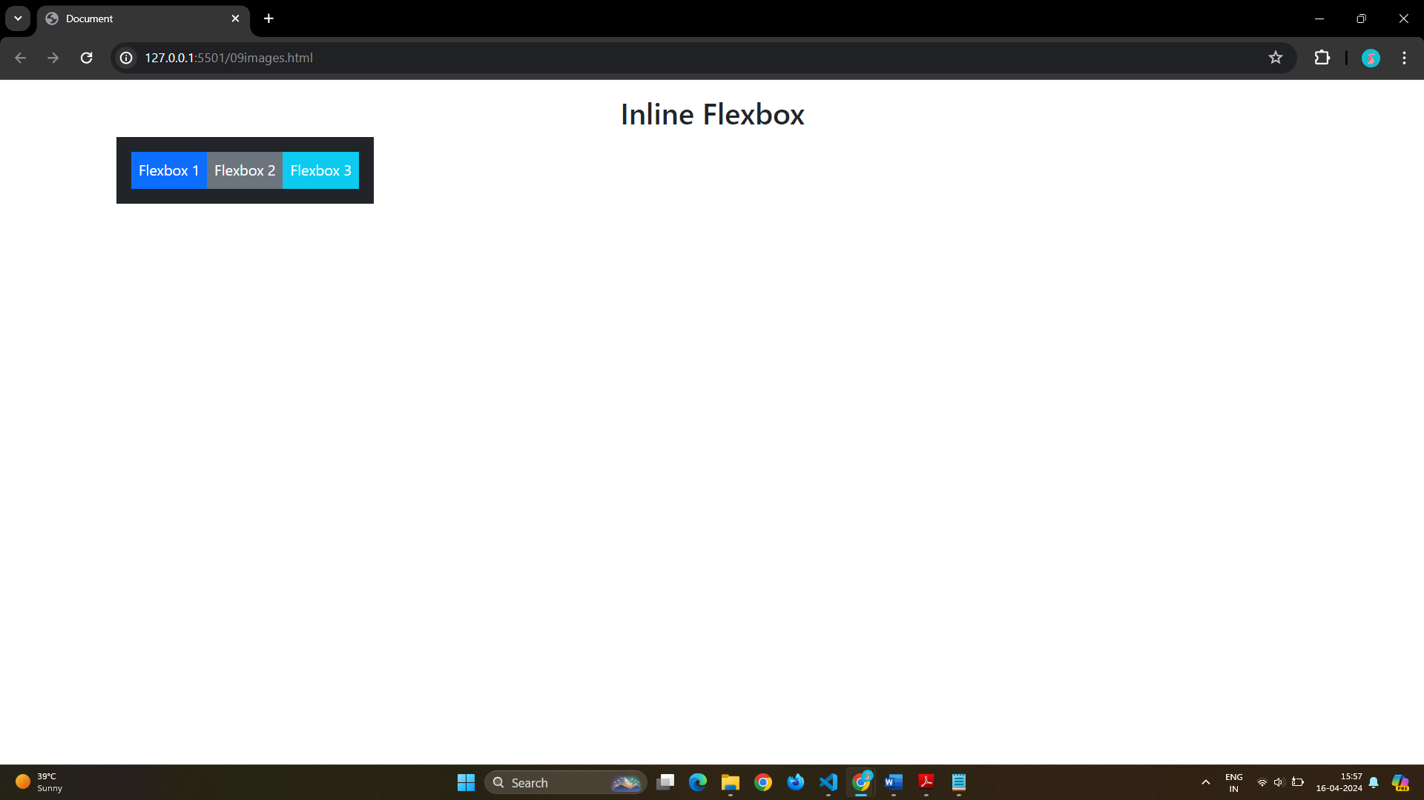

Horizontal Flexbox

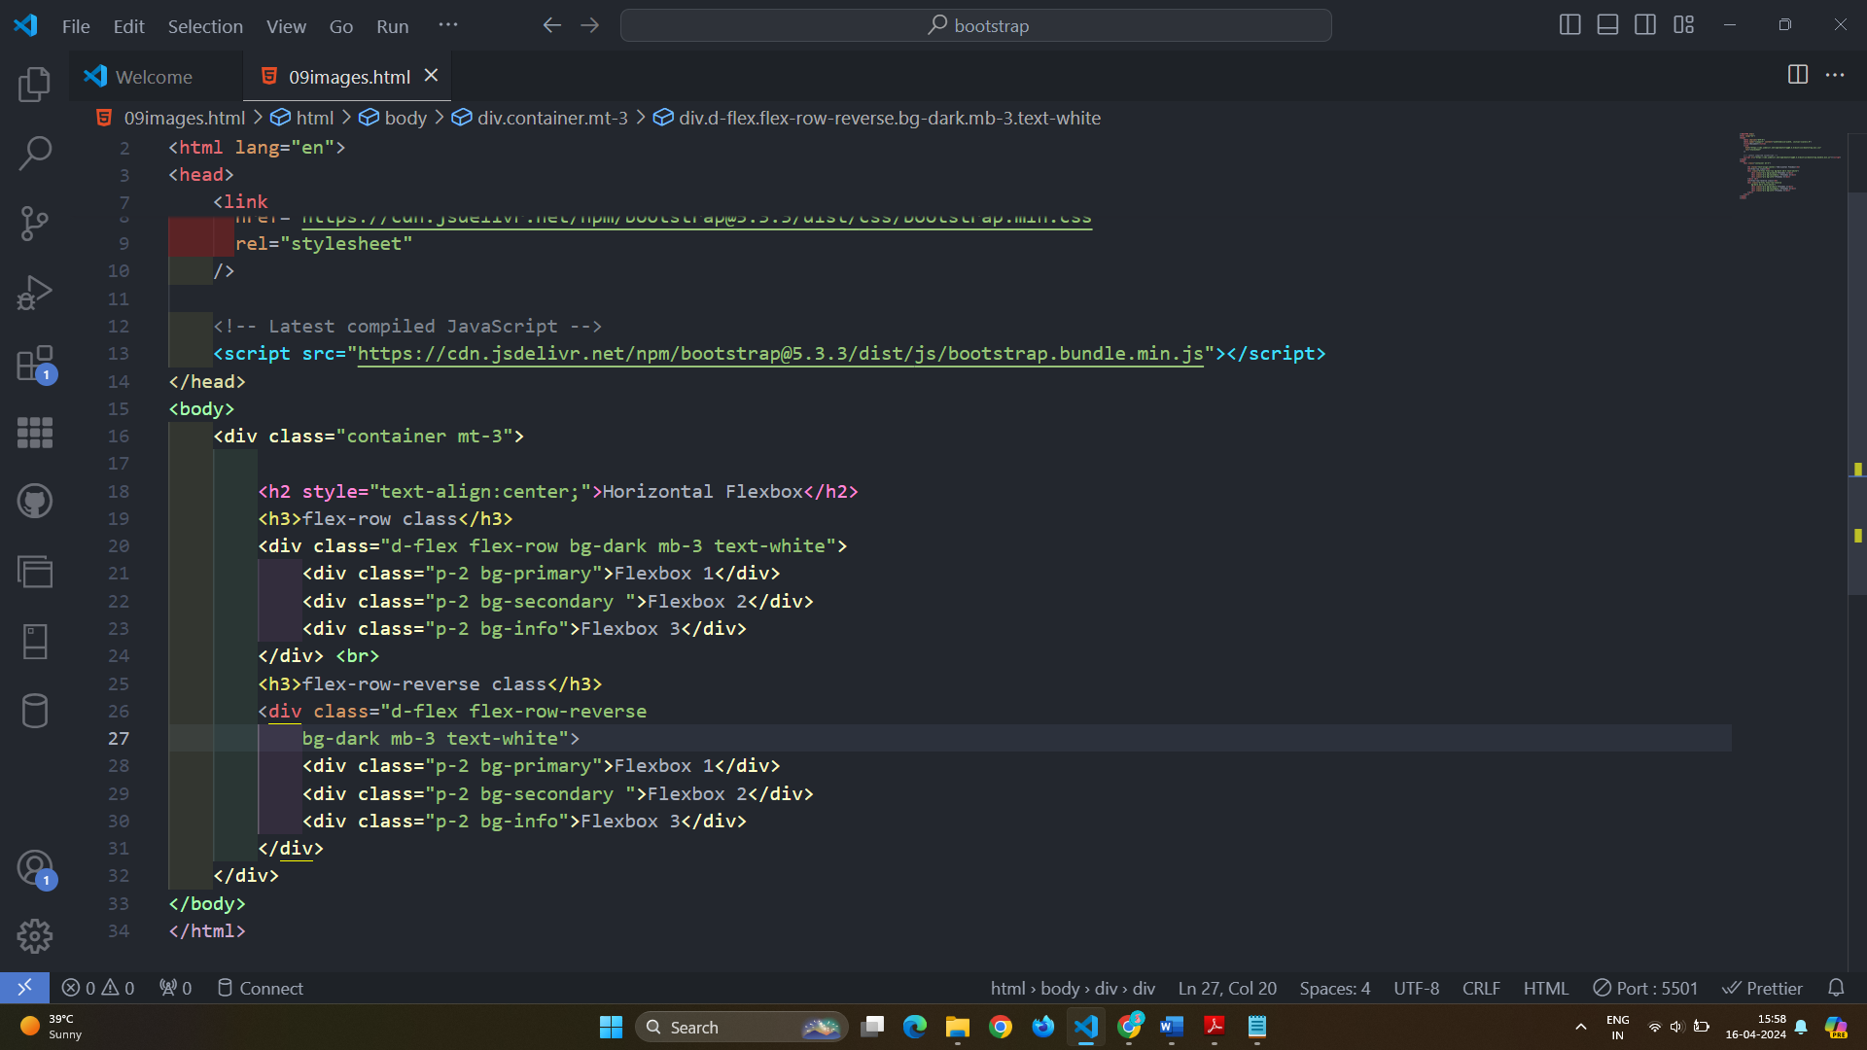

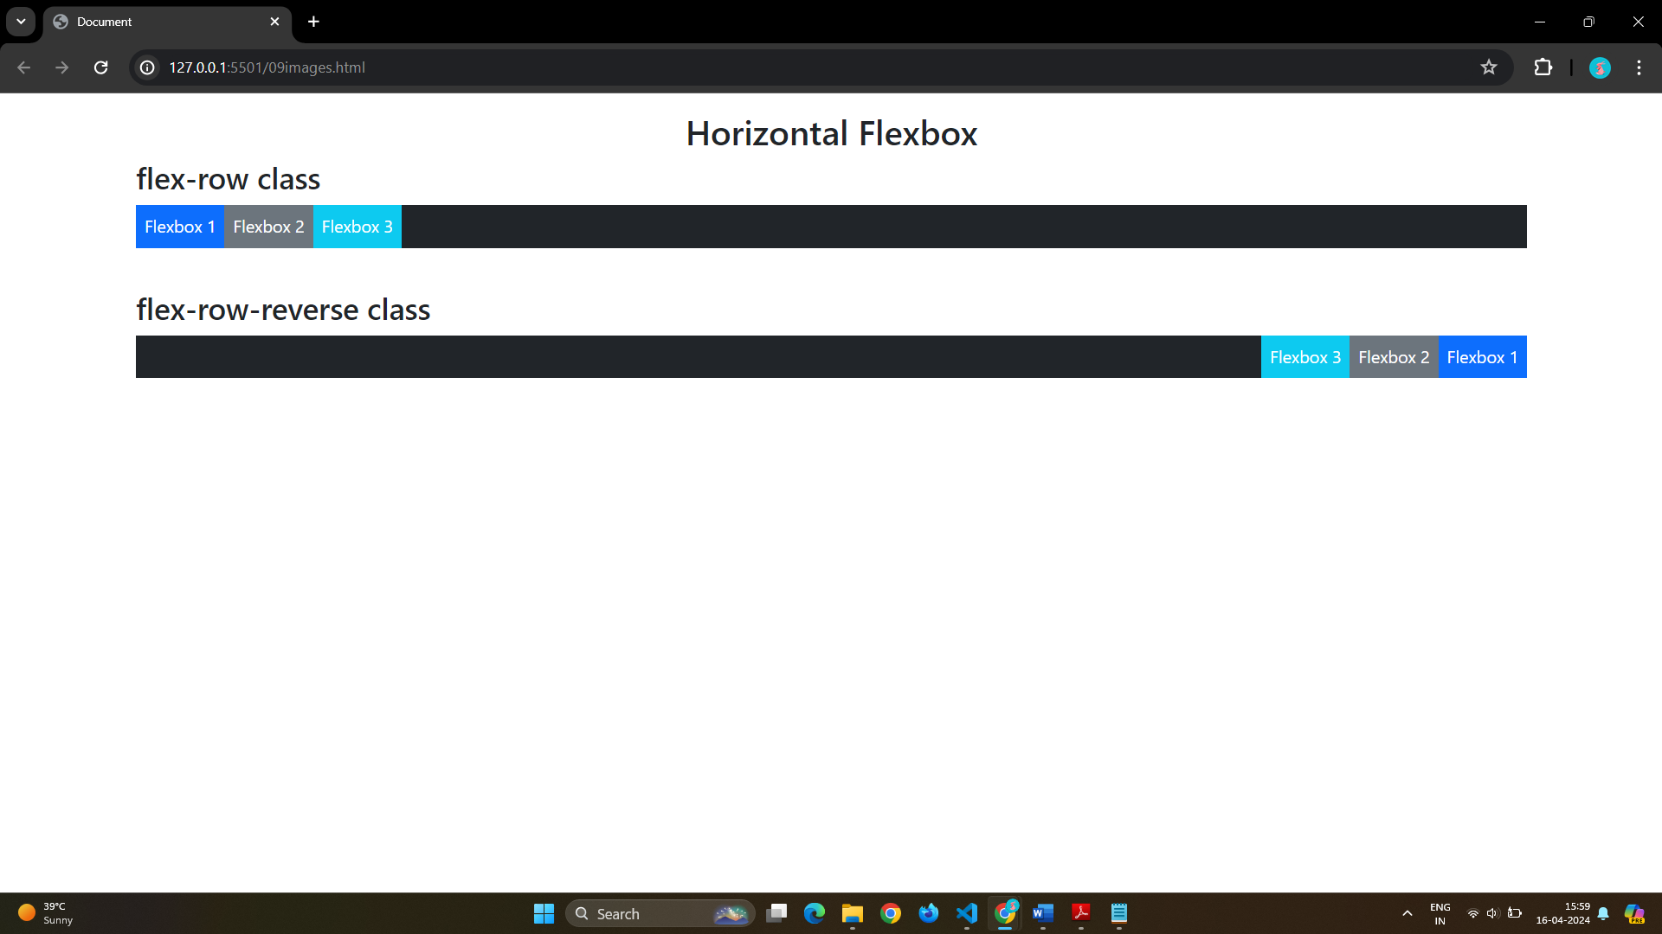

Vertical Flexbox

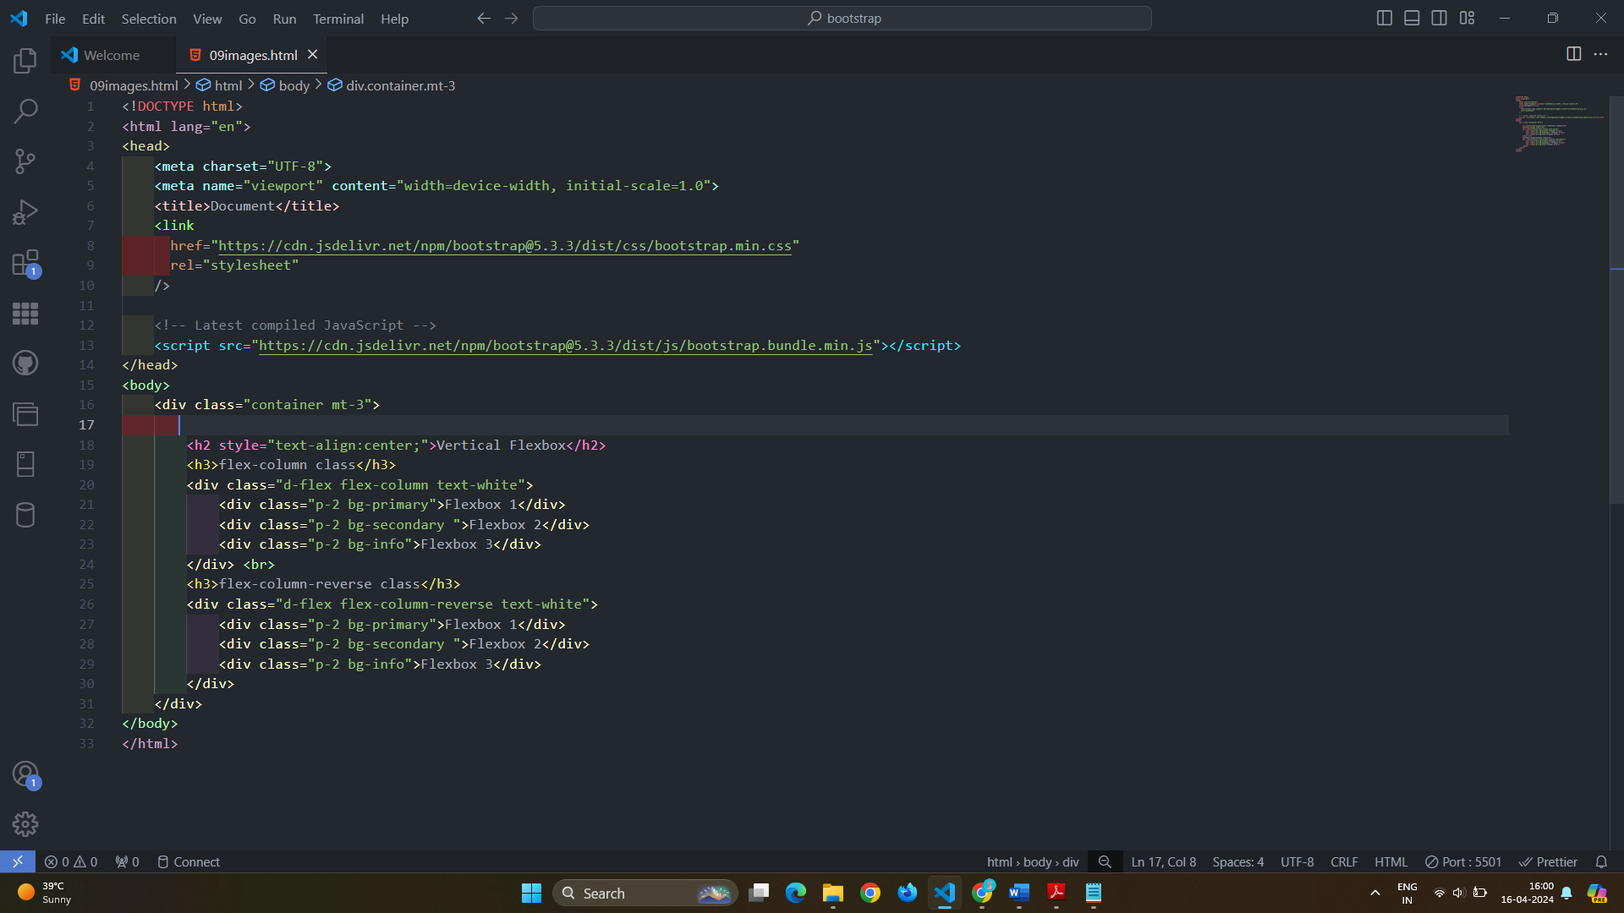

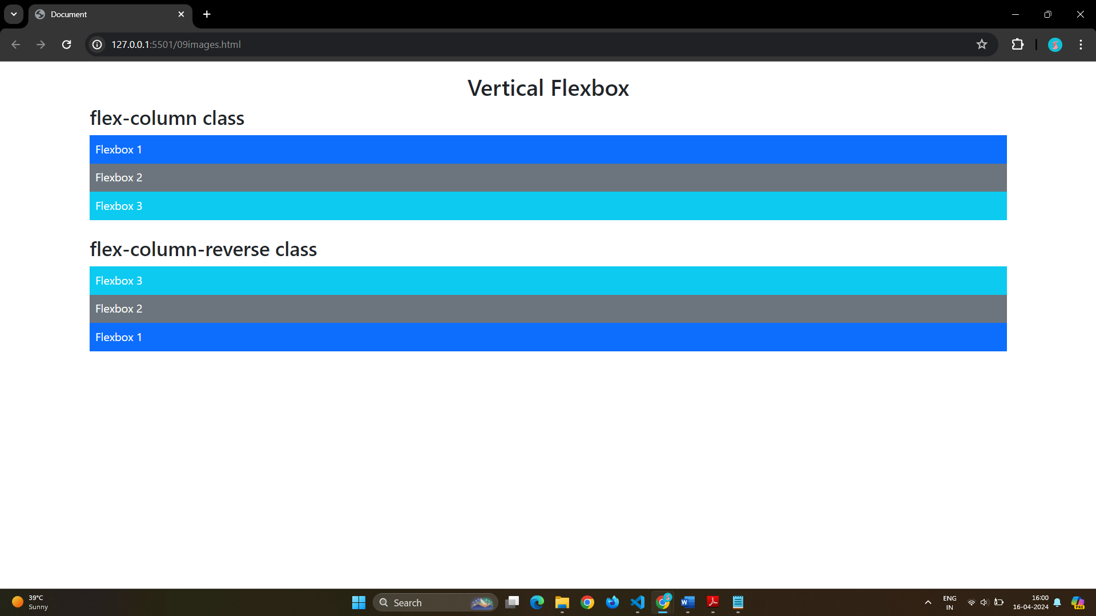

Justify Content Flexbox

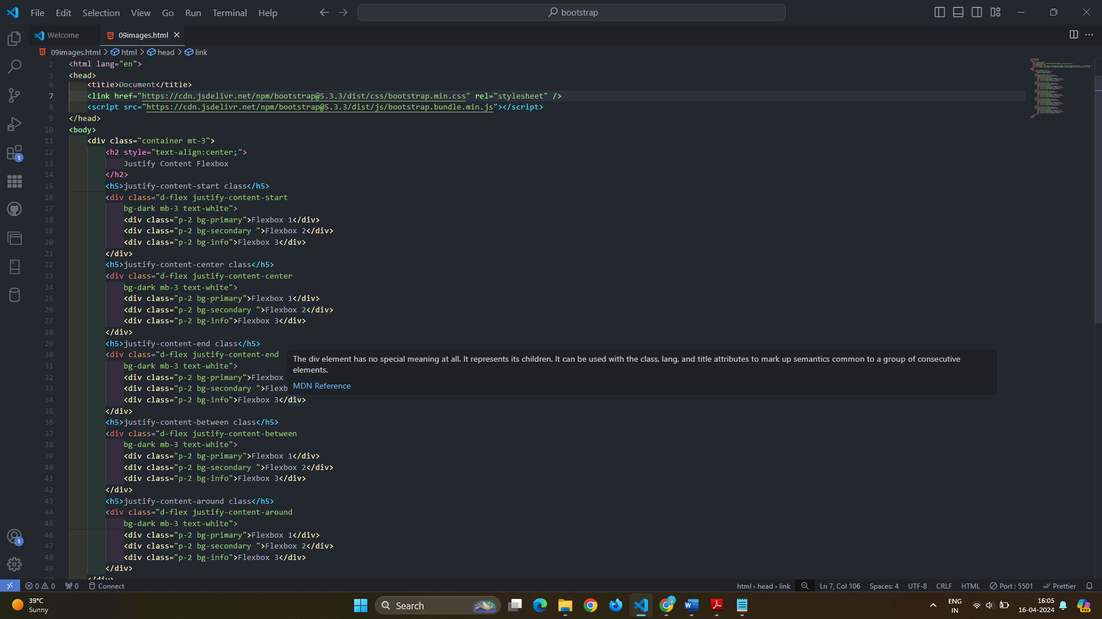

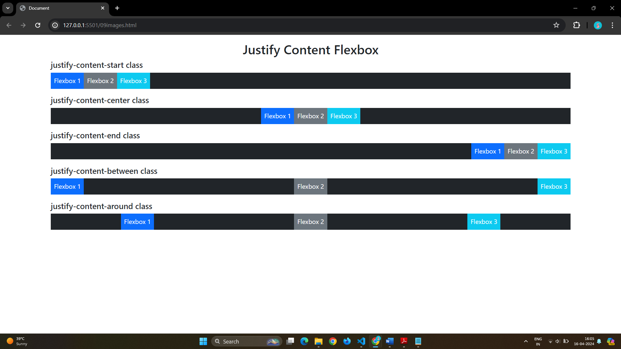

# Q 9]How can one create an alert in Bootstrap?

Ans} There are total Four alerts .

alert-success,

.alert-info,

.alert-warning

.alert-danger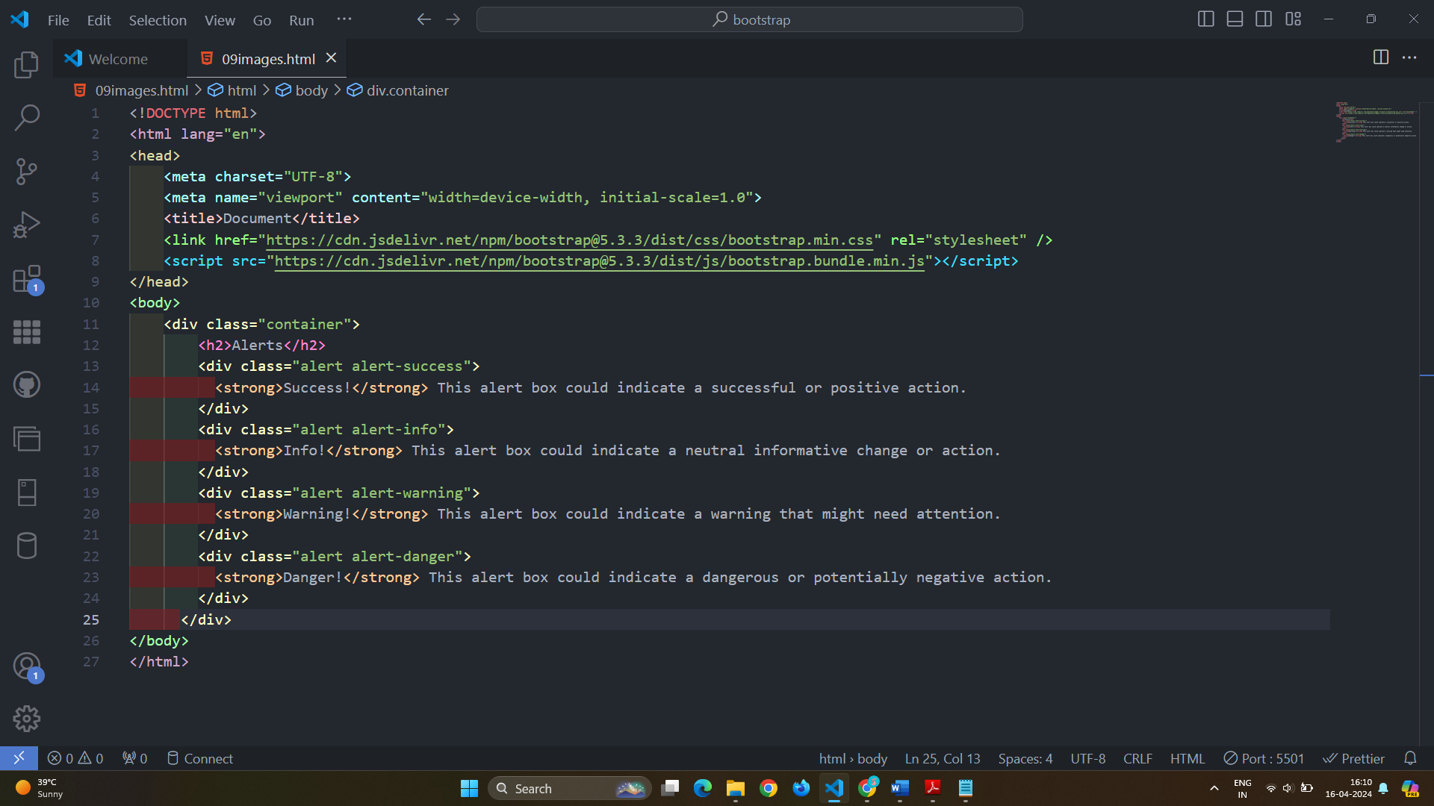

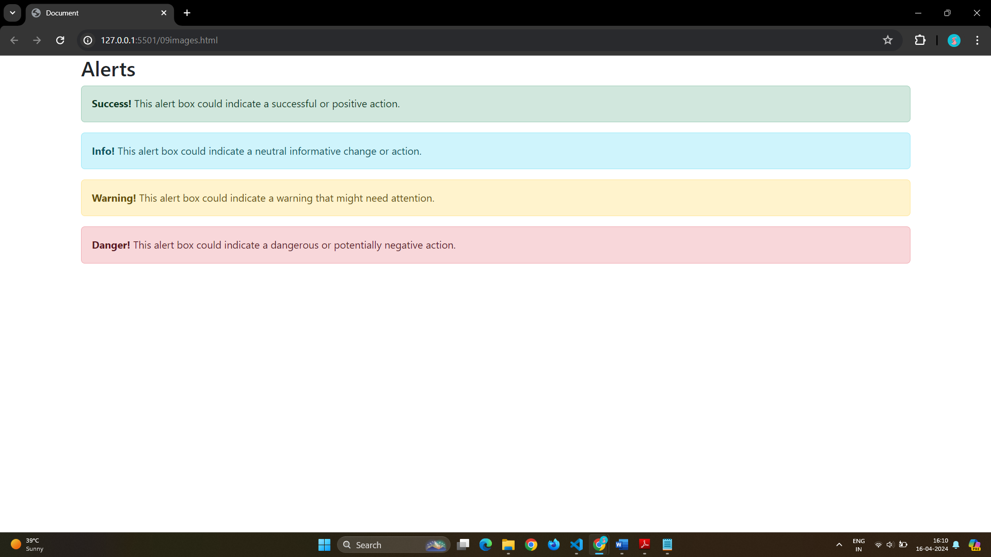

# Q 10]What is a bootstrap card and how would you create one?

Ans} A card in Bootstrap 5 is a bordered box with some padding around its content. It includes options for headers, footers, content, colors, etc.

A basic card is created with the .card class, and content inside the card has a .card-body class

The .card-header class adds a heading to the card and the .card-footer class adds a footer to the card

